SMITH CENTER
ELEMENTARY SCHOOL

Student/Parent Handbook
2021-2022

Building Mission Statement
Smith Center Elementary School

The mission of Smith Center Elementary School is to provide a safe and orderly environment where all students can learn. To insure the success of our students, the teachers and administration will continue to improve instructional effectiveness, frequently assess student progress and maintain high expectations for the quality of instruction and learning.

TABLE OF CONTENTS
BUILDING MISSION STATEMENT ………………………………………………………………………………………………. 2
ADMINISTRATION, FACULTY AND STAFF …………………………………………………………………………………… 5
ORGANIZATION …………………………………………………………………......................................................... 6
SCHOOL BUILDING ENTRANCES…………………………………………………………………………………………………. 6
PARENTAL CONCERNS……………………………………………………………………………………………………………….. 6
ARRIVAL TIME……………………………………………………………………………………………………………………………. 6
SCHOOL BUS TRANSPORTATION………………………………………………………………………………………………… 7
School Bus Activity Transportation Policy:
TELEPHONE USE AND MESSAGES………………………………………………………………………………………………… 8
CELL PHONES………………………………………………………………………………………………………………………………. 8
THE SCHOOL DAY………………………………………………………………………………………………………………………… 8
ABSENCES…………………………………………………………………………………………………………………………………… 8
ATTENDANCE……………………………………………………………………………………………………………………………… 8
Section 1-ABSENCES AND EXCUSES……………………………………………………………………………………. 9
Section 2- TARDIES…………………………………………………………………………………………………………….. 9
Section 3-UNEXCUSED ABSENCES………………………………………………………………………………………. 9
Section 4-SIGNIFICANT PART OF A DAY………………………………………………………………………………. 9
Section 5-ACTIVITY PARTICIPATION……………………………………………………………………………………. 9
BICYCLES/SCOOTERS………………………………………………………………………………………………………………… 9
BULLETINS AND NOTES FROM SCHOOL……………………………………………………………………………………… 10
Learning Packets:………………………………………………………………….……………………………………………. 10
SCHOOL BUILDINGS AND EQUIPMENT………………………………………………………………………………………. 10
CARE OF SCHOOL PROPERTY…………………………………………………………………………………………………….. 10
BOOK RENTAL…………………………………………………………………………………………………………………………… 10
CONDUCT AND DISCIPLINE……………………………………………………………………………………………………….. 10,11
WEAPONS AND DANGEROUS INSTRUMENTS……………………………………………………………………………. 12
SCHOOL SAFETY HOTLINE…………………………………………………………………………………………………………. 12
DISMISSAL………………………………………………………………………………………………………………………………… 12
HEALTH AND IMMUNIZATION………………………………………………………………………………………………….. 12
ILLNESS…………………………………………………………………………………………………………………………………….. 13
HEAD LICE POLICY…………………………………………………………………………………………………………………….. 13,14
HOMEWORK PHILOSOPHY………………………………………………………………………………………………………… 14
ELEMENTARY AFTER SCHOOL ASSISTANCE PROGRAM………………………………………………………………
GOAL……………………………………………………………………………………………………………………………….. 14
PURPOSE…………………………………………………………………………………………………………………………. 14
OBJECTIVES……………………………………………………………………………………………………………………… 14
EVALUATION…………………………………………………………………………………………............................. 14
AFTER SCHOOL DETENTION……………………………………………………………………………………………………… 15
INSTRUMENTAL MUSIC……………………………………………………………………………………………………………. 15
LOST AND FOUND…………………………………………………………………………………………………………………….. 15
FOOD ALLERGIES………………………………………………………………………………………………………………………. 16
LUNCH AND BREAKFAST……………………………………………………………………………………………………………… 16
LUNCH SCHEDULE……………………………………………………………………………………………………………………….. 16
INSUFFICIENT CHECK POLICY………………………………………………………………………………………………………. 16
MEDICATION ADMINISTRATION………………………………………………………………………………………………….. 17,18
PEANUT/TREE NUT ALLERGY GUIDELINES…………………………………………………………………………………… 19
SEVERE ALLERGY GUIDELINES…………………………………………………………………………………………………….. 20
LIBRARY-ELEMENTARY……………………………………………………………………………………………………………….. 20
MILK PERIOD………………………………………………………………………………………………………………………………. 20
PARENT-TEACHER CONFERENCES……………………………………………………………………………………………….. 20
PARTIES………………………………………………………………………………………………………………………………………. 20
RELEASE OF CHILDREN DURING THE SCHOOL DAY………………………………………………………………………. 20
RETENTION…………………………………………………………………………………………………………………………………. 21
REPORT CARDS…………………………………………………………………………………………………………………………… 21
STUDENT APPEARANCE ……………………………………………………………………………………………………………… 21
SCHOOL ENTRANCE AGE…………………………………………………………………………………………………………….. 21
ADMISSION OF ALL STUDENTS……………………………………………………………………………………………………. 22
SCHOOL VISITS……………………………………………………………………………………………..……………………………. 22
SCHOOL DRIVEWAY……………………………………………………………………………………………………………………. 22
SUSPENSION………………………………………………………………………………………………………………………………. 23
VISION AND HEARING SCREEN…………………………………………………………………………………………………… 23
DATES TO REMEMBER……………………………………………………………………………………………………………….. 24
EVACUATION PROCEDURES FOR OCCUPANTS WITH DISABILITIES …………………………………………….. 25
FIRE DRILL PROCEDURES …………………………………………………………………………………………………………… 25
TORNADO DRILLS………………………………………………………………………………………………………………………. 26
FIRE-TORNADO EMERGENCIES………………………………………………………………………………………………….. 26
SMITH CENTER ELEMENTARY SCHOOL ANHYDROUS DRILL PROCEDURE ………………………………….. 26
ANHYDROUS-AMMONIA EMERGENCY……………………………………………………………………………………….
TOXICOLOGY…………………………………………………………………………………………………………….……….. 26
FIRST AID……………………………………………………………………………………………………….………………….. 27
FIRE ESCAPE DIAGRAM……………………………………………………………………………………………………………… 28
ALTERNATE FIRE ESCAPE DIAGRAM………………………………………………………………………………………….. 29
TORNADO SHELTER DIAGRAM………………………………………………………………………………………………….. 30
INTERNET EXPECTATIONS…………………………………………………………………………………………………………. 31
INTERNET USAGE AGREEMENT…………………………………………………………………………………………………. 32
STATEMENT TO NON-RESIDENT PARENTS………………………………………………………………………………… 33
SCHOOL CALENDAR………………………………………………………………………………………………………………….. 34
PERMISSION FOR MEDICATION………………………………………………………………………………………………… 35
WAIVER OF CONFIDENTIALITY………………………………………………………………………………………………….. 36
PARENT INFORMATION ON SPECIAL EDUCATION ……………………………………………………………………. 37
HARASSMENT POLICIES AND PROCEDUERES……………………………………………………………………………. 38-43
STUDENT RECORDS POLICY……………………………………………………………………………………………………… 44-47
AHERA MANAGEMENT PLAN…………………………………………………………………………………………………… 48
AN EQUAL EMPLOYMENT/EDUCATIONAL OPPORTUNITY AGENCY………………………………………….. 48
NO CHILD LEFT BEHIND ACT……………………………………………………………………………………………………. 49,50
EMERGENCY SAFETY INTERVENTIONS…………………………………………………………………………………….. 51,52
HAZING/HARASSMENT……………………………………………………………………………………………………………. 53

BOARD OF EDUCATION
Theron Haresnape Jessica Weltmer Marty Hanson Steve Overmiller
Robert Dietz Tim Weltmer Jessica Hawkins
Roberta Reinking, Clerk Linda Robinson, Treasurer
ADMINISTRATION, FACULTY AND STAFF
Dustin McEwen…………………………………………………………………………………………………………….. Superintendent
Michelle Stamm………………………………………………………………..…………………………………………… Principal
Susan Panter……………………………………………………..…………………………………………………………. Secretary
Jolene Moss………………………………………………………………………………………………………………….. Kindergarten
Michelle Benoit…………………………………………………………………………………………………………….. Kindergarten
Stacey Rempe………………………………………………………………………………………………………………. Grade One
Darian Baumann…………………………………………………………………………………………………………… Grade One
Cally Rogers………………………………………………………………………………………………………………….. Grade Two
Anita Wolters………………………………………………………………………………………………………………. Grade Two
Ann Rust………………………………………………………………………………………………………………………… Grade Three/Four
Staci Buckmaster……………………………………………………………………………………………………………. Grade Three/Four
Amanda Lehmann………………………………………………………………………………………………………….. Grade Three/Four
Ellie Stansbury………………………………………………………………………………………………………………. Grade Three/Four
Katie Grabast………………………………………………………………………………………………………………… Grade Five
Matraca Baetz……………………………………………………………………………………………………………... Grade Five
Lori Ifland……………………………………………………………………………………………………………………… Grade Six
Travis Elliott …………………………………………………………………………………………………………………. Grade Six
Arla Homburg………………………………………………………………………………………………………………… Vocal Music
Heather Sasse………………………………………………………………………………………………………………. Library
Mike Rogers………………………………………………………………………………………………………………….. Physical Education
Bree Wilson………………………………………………………………………………………………………………….. Title I
Michelle Stamm…………………………………………………………………………………………………………… At Risk
Latham Foreman……………………………………………………………………………………………………………. Special Education
John Lambert………………………………………………………….……………………………………………………. Special Education
Alicia Brown …………………………………………………………………………………………………………………. Special Education
Mindy Wolfe………………………………………………………………………………………………………………… Pre-K
Risa Overmiller……………………………………………………………………………………………………………. Pre-K
Shari Brown………………………………………………………………………………………………………………….. Speech
Alana Williams-Dean……………………………………………………………………………………………………. School Nurse
Connie Rocker………………………………………………………………….…………………………………………… School Psychologist
Bette McNary………………………………………………………………………….…………………………………... Secretary
Kendall Allen ……………………………………………………………………………………………………………….. School Counselor
Kelly Allen…………………………………………………………………………………………………………………….. Para Educator
Karen Baetz………………………………………………………………………………………………………………….. Para Educator
Janet Barnes………………………………………………………………………………………………………………… Para Educator
Gina Brooks…………………………………………………………………………………………………………………… Para Educator
Shelly Faundez…………..…………………………………………………………………………………………………. Para Educator
Jennifer Herredsberg ……………………………………………………………………………………………………. Para Educator
Peggy Hobelmann ……………………………………………………………………………………………………….. Para Educator
Allaire Homburg ………………………………………………………………………………………………………….. Para Educator
Kelli Jones……………………………………………………………………………………………………………………… Para Educator
Katy Lange…………………………………………………………………………………………………………………….. Para Educator
Rosemary Linn………………………………………………………………………………………………………………. Para Educator
Mona Marler ……………………………………………………………………………………………………………….. Para Educator
Rhonda Overmiller…………………………………………………………….…………………………………………. Para Educator
Jenna Schoenberger …………………………………………………………………………………………………….. Para Educator
Vickie St. Clair………………………………………………………………………..……………………………………… Para Educator
Annette Wingerson………………………………………………………………………………………………………. Para Educator
Shelli Younger ………………………………………………………………………………………………………………. Para Educator
Don Threlkel………………………………………………………………………………………………………………… Custodian
Ryan Allen……………………………………………………………………………………………………………………. Custodian

GENERAL INFORMATION

ORGANIZATION
Smith Center Elementary School is composed of Grades Pre-K-6. School hours are 8:15 AM to 3:30 PM. Kindergarten meets all day every day.
There are a number of special program and services available to meet unique student needs. These are:
- Title I Reading and Math
- Learning Disabilities
- Speech and Language Development Services
- Adaptive Physical Education
- Pre-School Program
- School Nurse Services
- School Psychologist Services
- School Counselor Services

SCHOOL BUILDING ENTRANCES
Students at Smith Center Elementary are our most precious resource. Because of this we care about their learning environment and safety. As a result, during the school day, we will not allow parents, community members, or guests to enter into the halls or classrooms without an educational reason and consent from the office staff.

We know that many times students forget to bring items or need treats brought to school. It is SCE’s policy to have you leave the item or items in the office. The office staff will be happy to deliver them to your child.

Students need to be dropped off and picked up at the front doors. We reserve the circle drive for our bus students. In order to ensure their safety, please use the front doors to drop off and pick up your child.

During the first week of school you are welcome to walk your child to their classroom. After the first week of school, we ask that you leave them at the front door.

Thank you for entrusting Smith Center Elementary with your children. We also thank you for helping keep our building safe.

PARENTAL CONCERNS
Parents may have specific concerns throughout the school year and may wish to have their thoughts known. It is our wish that the parent first contact their child’s teacher. It may be, for example, that the teacher is not aware of a certain situation. After being informed, he/she will help solve the parent’s concern. If additional help is needed, the parent may then contact the building principal for additional support or help.

ARRIVAL TIME
Students will sit quietly in the lunchroom until the bell rings at 7:55. Students will report to their classroom where they will be dismissed if they want to eat breakfast. All buses are scheduled to arrive between 7:55 and 8:10, but no bus should, under normal weather conditions, arrive later than 8:10.

SCHOOL BUS TRANSPORATION
All bus routes serving the needs of the district’s students are to be proposed by the Superintendent of Schools with the approval of the Board of Education prior to the opening of the school year. The routes shall be planned so no student will be required to ride the bus longer than approximately one hour each trip. Routes will be based on the dispersion of the students to be transported, the roads, the load capacity of each bus, and the time necessary to travel the complete route.

School will be dismissed when the buses cannot run, with certain exceptions given, as in case of emergency or need. Emergency dismissal shall be at the discretion of the Superintendent of Schools or the administrator in charge in the case of his absence. Notification of early dismissal will be made known by broadcasting over the two nearby radio stations if time permits such notification to be helpful and by Redmen Alerts, the school’s text message service.
Discipline on the buses is to be supervised by the local administrators through the cooperation of the school bus drivers, their action to be that which is feasible under the exiting circumstances.

Continued misconduct or gross misconduct is considered as grounds for the administrators to refuse transportation to a student. Bus operators are to keep the administrators informed as to discipline problems on their bus so that they may receive assistance in the proper handling of these matters.

The drivers will not wait on students. Students transported on the buses shall be under the authority of and be responsible to the driver of the bus. During stormy or blizzard weather, bus drivers will discharge students only after they have made sure that parents are at home. In the event that parents are not at home, the students will be discharged at the next regular stop where adults are present.
School Bus Activity Transportation Policy:
When it is necessary to provide transportation for USD 237 students to and from a school sponsored activity, it will be the responsibility of the school to make arrangements for the transportation of all participating students.

When the school officials consider it desirable to use a school bus or buses, all participating students will ride in an assigned bus to and from the event. However, when parents request that their student return by means other than the bus, arrangements will be made as follows:

- Students will be released to their parents by reporting with their parents to the sponsor in charge.
- Students will be released to a designated adult upon presentation and verification of a written parental statement. The written release must be presented to the Principal one day in advance of the activity.
USD 237 shall transport only those students to and from school who reside within the USD 237 District boundaries. Special requests should be directed to the Superintendent of Schools who will determine each request on an individual basis.

TELEPHONE USE AND MESSAGES
The telephone is a business phone and should be used for business calls only. We want you to call the school when necessary, but students will be permitted to use the phone only in case of emergency. Except in an emergency, we will not call students or teachers from the classroom to the phone. All plans concerning after school activities should be made by the child and parent before coming to school. Messages will be taken and return calls made when necessary. Any changes in students after school plans require a note or phone call to the office. Except in cases of illness or official school business, long distance calls will have to be collect calls. Your cooperation in this matter will be greatly appreciated.

CELL PHONES
Cell phones are not allowed during the school day at Smith Center Elementary by students. If parents deem it necessary for students to have a cell phone at school, they will need to make arrangements with the principal who will have the final authority. The 1st time a student is caught with a cell phone during the school day, the phone will be confiscated and the parent will be called to come pick up the phone. The 2nd time a student is caught with a cell phone during the school day; the phone will be kept by the principal until the end of the semester.

THE SCHOOL DAY
School will be held each day scheduled except in case of severe weather or poor road conditions. In such situations the Superintendent’s judgment will govern, thus he shall cancel a regular day of school if deemed necessary.

ABSENCES
Parents should notify the school by telephone if their child will be absent from school for any reason. This keeps the school informed about the health of the child. It is for the student’s protection that we ask parents to call the school. If a phone is not available or you are unable to call during their absence, a note stating the reasons for the absence should be sent with the students upon his/her return to school.

ATTENDANCE
Parents are encouraged to send their children to school unless they are ill or there is an emergency in the family. Kansas Law requires regular school attendance.
“72-1113-C” of Kansas Law states, “Whenever a child is required by law to attend school and is enrolled in school and the child is inexcusably absent there from on either three consecutive school days or five or more school days in any semester, the child shall be considered to be not attending school as required by law. A child is inexcusably absent from school if the child is absent there from all or a significant part of a school day without a valid excuse acceptable to the school employee designated by the Board of Education to have responsibility for school attendance of such child.”

Section 1 – ABSENCES AND EXCUSES
- Excused absences are those that are caused due to medical or dental appointment, illness of the student, death in the family or some equally serious and unavoidable cause. In these cases, work missed may be made up with full credit. Students will have 2 days to make up work for each day absent. Special circumstances may occur. All absences, regardless of the cause will be recorded on the student’s attendance record unless the student has been excused for some specific school activity.
- Absences due to other conditions or situations approved in advance by the principal. In most cases, class work will be expected to be made up in advance of the absence. Credit will be given for the daily work made up.
- Excessive absences, regardless of the reason, can result in an unexcused absence by school authorities.
Section 2 – TARDIES
Students arriving after the 8:10 bell will need to stop in the office to be counted tardy. If the student does not have a parent notification for their late arrival, they will be considered an unexcused tardy. Unexcused tardies exceeding 5 in one quarter will result in after school detention. Excessive tardies, regardless of the reason, can result in an unexcused tardy by school authorities.

Section 3 – UNEXCUSED ABSENCES
All absences in which the excuse is unsatisfactory and without the consent or approval of school authorities will result in no credit given for assignments or examinations missed while absent.

Section 4 – SIGNIFICANT PART OF THE DAY
If a student is absent fifty percent (50%) or more of the scheduled school time during the AM session, the student is considered absent for that session. Likewise, if a student is absent fifty percent (50%) or more of the scheduled school time during the PM session, the student is considered absent for that session. A student who is absent more than sixty percent (60%) of the scheduled school time during a school day is considered absent for the full day.

Section 5 – ACTIVITY PARTICIPATION
Students who intend to participate in evening school activities at the Elementary School must attend the afternoon session of the scheduled school day. Special arrangements may be made with the principal in advance if non-attendance is not for health reasons.

BICYCLES/SCOOTERS
All bicycles/scooters should be parked in the designated areas. No bicycles/scooters are to be ridden on the playground during school hours on school days.

A child riding a bicycle/scooter should know all the rules of the highway. Riders must observe the appropriate rules. Students not observing rules pertaining to bicycles/scooters will be required to leave their bicycle/scooter at home. Scooters should be left outside the building.

BULLETINS AND NOTES FROM SCHOOL
From time to time during the year, bulletins and/or notes will be sent to parents by way of their student. Parents are urged to read all notes and bulletins sent home to avoid misunderstandings of the school program. Check with your child from time to time for these bulletins.

Learning Packets:
Each Thursday students will be taking home “Learning Packets”. Materials that should be included, but not restricted to, are communications from the teacher, office notes, completed assignments, etc. These papers should be reviewed and the packet signed by the parents and returned to school the following day.

SCHOOL BUILDINGS AND EQUIPMENT
On regularly scheduled school days, the buildings are officially unlocked at 7:50 AM and locked at 5:00 PM. The buildings are locked over the weekends and vacations.

CARE OF SCHOOL PROPERTY
We encourage all students to be proud of their school and we feel it is the duty of each student to respect school property. Any student who shall intentionally or accidentally destroy or damage any school property, or who shall deface by cutting, writing or drawing on any fence, furniture, building, or other school property, shall immediately compensate for such damage. Students who refuse may be suspended from school until such compensation has been made.

Damage to school property during out-of-school hours should be reported by school employees to the building principal. The principal will report the damage to the Superintendent who will report the damage to the Board of Education. The Superintendent will report the same to the County Attorney for investigation by the proper law enforcement officials.

BOOK RENTAL
There is a $50.00 book rental for Kdg.-Grade 6 for the 2021-2022 school term.

Students will be expected to return books checked out in their care at the close of the school term. Abusive care given to school-owned books will result in students being assessed repair or replacement costs for the book. Fair wear and tear is not considered abusive care. Assessment for lost or damaged books is the responsibility of the building principal.

CONDUCT AND DISCIPLINE
Self-discipline is a sign of maturing. It is achieved only through constant practice. To help strengthen the student’s character and to develop self-discipline, students are requested and expected to observe the rules and regulations of the school and of common courtesy. Smith Center Elementary students are expected to take responsibility for their actions.

Students are expected to conduct themselves in a manner which is in keeping with the activity in which they are involved, respect the rights of others, and obey safety rules and regulations.

In order to guarantee all the students at Smith Center Elementary School an excellent climate for learning, the staff will use the following guidelines for student conduct:
General Playground Rules:
- Use all equipment properly
- Use no abusive language, rude gestures or “put downs”
- Keep hands, feet and objects to yourself
- Follow teacher instruction
- Ask permission to leave the playground

General Hallway Rules:
- Walk at all times
- Avoid loud talking or noises which might disturb others
- Keep hands, feet and objects to yourself
- Follow directions

General Cafeteria Rules:
- Walk and move in single file
- Follow directions of the supervisor
- Maintain a low level of talking
- Use appropriate table manners
- There will be no exchanging of food items

General Classroom Rules:
- Follow teacher giving directions
- Be considerate of others’ effort and work
- Teachers may have other classroom rules

Each teacher has a set of discipline steps which she/he will follow. All teachers follow similar steps and this should help the student. The final step is sending the student to the office.

In general, when a student is sent to the principal’s office the following procedure will be followed:
- During the first visit, the student and principal will discuss the problem and appropriate action will be taken. A computerized record will be started. (Each discipline case is unique. In some cases parents may be called immediately).
- The second time the student is sent to the office, the parents will be contacted by a staff member to make them aware of the problem.
- The third visit, the principal may contact the parents and a student-parent-principal conference may be held, or the child may be required to call the parent.
- Continued behavioral problems and classroom disruptions may result in out-of-school or in-school suspension.

WEAPONS AND DANGEROUS INSTRUMENTS
A student shall not knowingly possess, handle or transmit any object that can reasonably be considered a weapon. For example, but not limited to, pocket knives, guns or unfired shells. Weapons or dangerous instruments will not be permitted:
- on the school ground during, before or after school hours
- on school grounds at any other time when the school is being used by any school personnel or school group; or
- off of the school grounds at a school activity, function or event

SCHOOL SAFETY HOTLINE
On August 1, 1999, a school safety hotline was established in cooperation with the Kansas Highway Patrol. This hotline is a toll free number available 24 hrs. per day, 365 days per year to give students, parents and community members the opportunity to report any impending school violence. This hotline gives individuals the opportunity to anonymously report any potential violence.

THE KANSAS SCHOOL SAFETY HOTLINE NUMBER IS 1-877-626-8203

DISMISSAL
Bus students will be dismissed to the buses between 3:14 PM and 3:17 PM. Non-bus students will be dismissed at 3:30 PM. Buses will load on the east side of Smith Center Elementary School.

HEALTH AND IMMUNIZATION
Any student entering school or enrolling in a Kansas school for the first time shall be required
to present to the building principal, or his designated representative, proof of immunization of certain diseases and a current physical or documents to satisfy statutory requirements.

Students who fail to provide said documentation as required by law may be excluded from school by the superintendent or the designated representative until statutory requirements are satisfied. Notice of exclusion shall be given to the parent/guardians as prescribed by law.

Exceptions to this policy are permitted only under the following conditions:
- Certification from a licensed physician stating the physical condition of the child to be such that the tests or inoculations would seriously endanger the life or health of the child.
- A written statement signed by one parent or guardian that the child is an adherent of a religious denomination whose religious teachings are opposed to such tests or inoculation, accompanied by a signed letter from the leaders of the local denomination, stating that the parents and/or child is a member of such denomination, and such denomination does, in fact, oppose such tests or inoculations.

ILLNESS
When a child becomes ill at school, parents will be notified. If the parents cannot be reached, the person listed on the “In Case of Illness” form will be notified. If no one can be reached, the child will be kept at school. No child will be sent home unless there will be someone to care for him/her.

USD 237 will follow the CDC (Center for Disease Control) recommendations for sickness and disease at school. Students with a fever of 100 degrees or greater should stay home for at least 24 hours after they no longer have a fever without the use of fever reducing medicine. Students with vomiting should stay home for at least 24 hours after last vomit. Students with diarrhea should stay home for at least 24 hours after last diarrhea episode. Sick students are not to attend school events i.e. following the same guidelines as stated above.

HEAD LICE POLICY
A. Head lice checks will be done as needed.
B. If head lice or nits are found on a student:
a. The student will not be singled out around other classmates. Confidentiality will be maintained.
b. Parents will be called to come get the student from school and be instructed to
treat the student with head lice treatment and comb out nits before returning to
school. The entire family will be encouraged to be checked and treated for head
lice.
c. A Head Lice letter will be sent home to the entire grade level of that student
alerting parents of the fact head lice has been found in that grade level. There
will be recommendations and information on the letter for parents to be pro-active with the head lice situation.
d. In order to be re-admitted back to class, the student will pass a nit check.
e. Starting the next morning, each student will bag their individual belongings and
hang on their hook in the classroom. This will continue until the grade level has
been without findings of head lice or nits for three weeks.
f. That particular grade level will be checked weekly for head lice and nits until
they are without findings of head lice or nits for three weeks.
g. If the student’s length of hair warrants, the students of that grade level will be
asked to keep their hair pulled back in pony tails or braids.
h. The classes will be reminded not to share hair bows, ties, barrettes, hats or
scarves. The students will be reminded not to brush, play with, touch or “fix”
each other’s hair at school. Brushes and combs are not necessary to have at
school.
- The classroom may be treated with lice treatment as conditions warrant.
j. The buses may be treated with lice treatment as conditions warrant.
C. Parents will be reminded to check the student’s hair at home occasionally in order to be
proactive.
D. Parents will be encouraged to inform the school nurse if head lice is found at home to
allow the school to be proactive in containing and controlling head lice at school.

The Following 2 week regimen is recommended to treat head lice infestation
Day 1: Apply head lice shampoo (following the instructions on the package) followed by a thorough fine tooth wet combing. This should kill most adults
and nymphs and remove most viable nits.
Day 2-6: Daily apply ordinary shampoo followed by cream rinse and a thorough fine
tooth wet combing. This should remove additional adults, nymphs, and nits.
Day 7: Apply head lice shampoo (following the instructions on the package)
followed by a thorough fine tooth wet combing. This should kill and remove
most remaining adults, nymphs, and some nits.
Day 8-14: Daily apply ordinary shampoo followed by cream rinse and a thorough fine
tooth wet combing. This should remove residual adults and nymphs.

HOMEWORK PHILOSOPHY
Learning is a continuous process that involves the home as well as the school. The learning connection at home should involve many different kinds of processes. The assigning of homework should be at the professional discretion of the teacher when he/she feels it is needed,

Homework is defined as:
- Completion of unfinished work
- Extension of a unit study – projects, reports, enrichments beyond the guided
practice in the classroom
- Family Projects – skill and/or drill activities, reading, cultural enrichments, remediation
library assistance, interviews, recommended T.V. programs, science projects

ELEMENTARY AFTER SCHOOL ASSISTANCE PROGRAM
GOAL
To facilitate the student to achieve a sense of membership within the framework of the school system and to understand that the student is responsible for contributing to the ultimate outcome of his/her future.

PURPOSE
To identify students demonstrating “at-risk” behaviors and tendencies and to design and implement an individualized instruction package including study skills, instruction and tutorial assistance in problem areas.

OBJECTIVES
- To improve academic achievement
- To develop social skills
- To promote appropriate, responsible behavior in school
- To heighten self-image

EVALUATION
Periodic review of individual students frequently attending the program will be evaluated by the staff during the school term. Revisions will be made in the program as warranted by staff observations evaluating the effectiveness of the program.

AFTER SCHOOL DETENTION
Students choosing to act inappropriately or are observed as showing a marked lack of responsibility for attempting to meet their academic requirements in school will not be allowed to deprive their peers and classmates of their opportunity to be provided a quality educational program. This disruptive behavior forces the teachers, principal, psychologist, nurse and classroom aides to redirect their efforts away from the vast majority of students appropriately involved in learning, to address these unnecessary disruptive behaviors.

THEREFORE………………….

A monitored study area has been established Monday through Thursday for disruptive students, as described above. When inappropriate and/or academic irresponsibility has become excessive, students will be required to stay after school in this monitored study area from 3:30 PM until 5:00 PM. Satisfactory completion of assigned work and appropriate conduct are required or the student returns the next night. Our present system of behavior management will continue to be used for lesser concerns.

The student’s parents will be notified when their child needs to stay after school and 24 hours notice will be given unless the parent chooses to use the service when notified that day. However, the student will stay as scheduled once the parent has been notified and the date set. Once the referral is received, reviewed and approved by the principal, the child is expected to stay. If he/she completes the unsatisfactory or missing work prior to a date being confirmed with parents, students will be expected to stay and work on current homework. The student will receive additional credit for this work when it is completed satisfactorily. Parents will be expected to pick up their child promptly at 5:00 PM at the west main entrance.

Students will be instructed to come to the monitored study area right after school. They can take a few minutes to use the restroom and then will not be allowed to leave the classroom for any reason until it is time to go home.

The purpose of this program is to promote skills development and grade improvement, as well as conduct and responsibility. However, satisfactory completion of assigned work and appropriate conduct are required during this program or the student will be required to return the next night.

INSTRUMENTAL MUSIC
An instrumental music program is part of the Smith Center Elementary School curriculum. Fifth and sixth grade students may enroll in this program. They will be bused to the Jr./Sr. High for band every day.

The district owns a few instruments which are available for rent. Students will need to contact the band instructor if interested.

LOST AND FOUND
Many articles of clothing are placed in the “Lost and Found” box each year. Parents can help their children avoid such losses by marking the clothing, gym shoes, book bags, etc. with the name of the child.

FOOD ALLERGIES
If your student has a known food allergy, please contact the SCE Office. Arrangements will be made upon the return of appropriate forms.

LUNCH AND BREAKFAST
Our school cafeteria serves a balanced lunch and breakfast. Breakfast is available to all students from 7:55-8:10 AM. The menu will consist mainly of juice, milk, cereal, rolls, muffins, biscuits, a meat and a variety of fruits. The cost is $2.50 for adults and $1.75 for students. Reduced price is 30 cents.

Eligibility for free or reduced breakfast is the same as for lunch.

The following lunch fees were established for this school term.

Grades K-6 $2.70
Adults $4.00
Extra Milk .50

Elementary pupils will pay for breakfast and lunches in the Smith Center Elementary School office.

LUNCH SCHEDULE
Lunch periods will run from 11:00 AM to 12:15 PM

INSUFFICIENT CHECK POLICY
Checks accepted by U.S.D. 237 from students or parents for payment of any school fees that are returned as insufficient funds will be handled in the following manner:
- Parents will be notified by certified letter with return receipt requested immediately
when their check returns because of insufficient funds.

- Should the check not be reclaimed and proper financial restitution made, the Superintendent of School shall refer the matter to the County Attorney for legal action.

Negative Account
The school lunch program requires that the lunch program operate on a cash basis. Elementary students will pay for lunches at Smith Center Elementary and Junior/Senior High students will pay for their meals at the High School building. Families with students at both buildings can pay at either one. A lunch account will be deemed bad credit when a family with a single student in the program reaches a negative balance of $100 or a family with two or more students in the program reaches a negative balance of $200. At this time, the responsible account holders must make suitable arrangements with the district to bring the balance out of the negative, or collections will be sought. No child will be denied a breakfast or a lunch by school officials.

Administering Medication During School Hours
BOARD POLICY:
The supervision of medications shall be in strict compliance with the rules and regulations of the board as carried out by district administrators.

ADMINISTRATIVE PROCEDURE:
- A student is eligible to take medication at school if it is to be given at a specific time of day during regular school hours or if it is to be given more than three times a day. Unnecessary medication administration at school is strongly discouraged.
- Signed permission from the parent/legal guardian and a written order from a person licensed to practice medicine or dentistry in the State of Kansas or other competent jurisdiction are required for administration of controlled and emergency medications in junior high and high school and all medications in the elementary setting. Over the counter medicines for elementary students require parent/legal guardian signed permission only.

- The order should include the following:
- Name of student
- Diagnosis/reason for medication
- Name of medication to be given
- Dosage to be given (A new physician written order will be required for dosage changes)
- Times to be given
- Method of administration
- Expected duration of treatment
- Parent/legal guardian is responsible for:
- Written request for medication administration to school nurse/medical aide
- Obtaining physician or dentist order
- Supplying medication in the original container
- Authorizing school health services personnel to exchange information with the attending physician and personnel from the dispensing pharmacy.
- The school nurse/medication aide is responsible for:
- Keeping medications locked in a cabinet and/or small locked container for refrigeration.
- Counting all regulated medications when received and verifying with at least one other adult (lawful custodian or school employee)
- RN only – instructing unlicensed school personnel who have been identified as necessary to implement the administration plan and documenting training and supervision.
- Seeing that school personnel observe students for desired and untoward effects.
- Completion of medication card

- Termination
- Short-term medication: The medication plan will be terminated when medication supplied by the parent/legal guardian has been administered.
- Long-term medication/PRN (as needed): during the school year the termination of a medication plan by the parent/legal guardian, prescribing physician, or school must be by written notice.
- The Permission for Medication Form must be updated at the beginning of each school year.

3. Self –Administration:
a. The self-administration of medicine for the treatment of anaphylactic reactions or asthma is allowed for students in grades K-12. To be eligible, a student shall meet all requirements of this policy. Parents/legal guardians shall submit a written statement from the student’s health care provider stating:

- The name and purpose of the medication;
- The prescribed dosage;
- The conditions under which the medication is to be self-administered;
- Any additional special circumstances under which the medication is to be
administered; and
- The length of time for which the medication is prescribed.
b. The statement shall also show the student has been instructed on self-administration of the medication and is authorized to do so in school.

c. An annual renewal of parent/legal guardian authorization for the self-administration of medication will be required.

d. USD 237, and its employees and agents, which authorize the self-administration of medication in compliance with the provisions of this policy, shall not be liable in any action for any injury resulting from the self-administration of medication, and written notification in this regard is provided to the parent/legal guardian.

e. Parent/legal guardian shall sign the waiver of liability provided on the Permission for Self-Administration of Medication form.
f. Other non-regulated prescription and/or over-the-counter medications may be self-administered by students at the Jr/Sr. High level unless parent/legal guardian requests supervision. Additionally, the following principles apply:
i. Students with chronic conditions should have a record of the condition and prescribed medications on file in the health room.
ii. Students should carry only a day’s supply of medication in the original container.
iii. Students should not give medication to another student.
iv. Building principals will have final authority to revoke medication privileges.

USD 237
Peanut/Tree Nut Allergy Guidelines
USD 237 has a number of children who suffer severe allergies to peanuts, tree nuts and/or by-products of both. We are asking for your full support in order to provide a safe environment through the school year for students who suffer this life-threatening allergy.
Some facts:
This life-threatening allergy is not simply an ingestion allergy. These children can suffer anaphylactic shock and death from a trace amount of the allergen, which might be airborne or left as a residue on a surface he/she touches. If this were simply a matter of not eating the offending item, it would not be so dangerous.
The number of children diagnosed with peanut/tree-nut allergies has more than doubled in the past five years.
Peanut/tree-nut allergies account for 92% of all severe and fatal allergic reactions in children. One in five children with food allergies will have a reaction while at school.

What will this mean to USD 237 school family? Basically, we are asking your full support in our goal to make this school as safe as possible for our children.
To Students:
Students are asked to voluntarily refrain from bringing anything containing peanuts or tree-nuts in their lunch box or as a snack. Our cafeteria will not serve any products that contain peanuts, tree-nuts or by-products of either.

To Parents:
Parents are asked to voluntarily choose not to pack anything containing peanuts or tree-nuts in their child’s lunch box.
Parents are asked to voluntarily choose not to send anything to the school containing peanuts or tree-nuts for snacks, treats, or refreshments. Please read labels before sending any food items to school.

While we understand this may present an inconvenience, it is our hope that everyone will agree the safety and well-being of our children is of utmost importance. When a child’s life is at stake, we must work together to make our school as safe as possible for children with this life-threatening allergy.
Thank you for your cooperation and support.

District Severe Allergy Guidelines

Students with known history of severe allergies:

1. If student carries emergency meds have Self Administration of Medicine form completed at least annually.
2. Follow the Standardized Health Care Plan for Anaphylaxis

LIBRARY-ELEMENTARY
1. When students borrow a book or magazine and it is lost or damaged, the student who checked out the material will pay the replacement cost.
2. Students who have overdue materials will be reminded by the librarian through weekly overdue slips. If a student loses a book or magazine and pays for it, then finds it, the student will be reimbursed the amount paid.
3. Students will be limited to a certain number of materials that can be checked out at one time.

MILK PERIOD
Milk for Pre-K students will be $25.00 per semester. Please purchase milk for students either by the semester or by the year for $50.00. Milk for kindergartners will be $35.00 per semester. Please purchase milk for students either by the semester or by the year for $70.00. If the parent does not want the student to drink milk for snack, water will be provided.

PARENT-TEACHER CONFERENCES
Regularly scheduled parent-teacher conferences will be held at the end of the first nine weeks and the end of February. Additional conferences may be held at any time with the teacher and/or the principal. Please call the office if you wish to schedule a conference.

PARTIES
Room parties include Fall Festival, Christmas and Valentine’s Day. These parties are the mutual responsibility of the teacher, parents and the children in that room.

RELEASE OF CHILDREN DURING THE SCHOOL DAY
If it is necessary for your child to leave school during the school day for any reason, please inform the student’s teacher or the school office either by written note or by phone.

We ask that you come to the office, and we will call the child to the office. You will need to sign for the student’s release from school. Dismissals from the classroom must be cleared through the office.

RETENTION
Teachers shall recommend, to their building principal, pupils that should be considered for retention. Teachers shall notify parents, and principal, after the end of the third nine weeks.

Teachers, principals and parents shall study the problem of the student and seek to reach a conclusion that best benefits the student.

REPORT CARDS
Report cards will be sent home with the students at the end of each nine weeks or passed out at parent teacher conferences.

STUDENT APPEARANCE
The objective of the elementary school is to help each student reach his/her highest level of achievement. Good personal hygiene, grooming and dressing habits contribute to a student’s general well-being and health.

We can, as parents, make a better decision daily regarding appropriate dress for the current weather conditions than a policy can address with so many variables like a warm March or a cold, rainy April and we can only trust that others will make equally responsible decisions on a daily basis. Therefore, it is left to you, as a parent, to determine when you feel comfortable with your child wearing shorts to school. The same applies to wearing coats, hats and gloves during inclement weather. Students almost always go outside daily for recess if only for a few minutes so they will obviously need to dress with the weather conditions in mind.

Wearing apparel that displays obscene, profane, indecent pictures and/or statements, or has pictures or statements regarding tobacco or alcohol products shall be considered not appropriate attire for school. In such cases, appropriate apparel will be provided, if available, or the student may wear the garment inside out. Parents will be notified of inappropriate apparel. The student will not be allowed to attend class until the wearing appeal is appropriate.

Hats or caps are not allowed to be worn while in the school. Students are asked to remove hats or caps as soon as they enter the facility.

SCHOOL ENTRANCE AGE
Any child, who will attain the age of six years on or before August 31, shall be eligible to attend first grade in the school district in which the child resides. Any child who will attain the age of five years on or before August 31 of any school year shall be eligible to enter Kindergarten.

ADMISSION OF ALL STUDENTS
Students entering USD 237 will meet the following requirements:
1. Birth certificate validating the student’s birthday must be presented at the time of enrollment.
2. Record of immunization as required by state laws or objections to immunizations as provided for by state laws must be filed with the principal at the time of enrollment.
3. A record of all grades and/or credits, any standardized test information, dates of enrollments, records of attendance and the recommendation for placement from a non-accredited/home school last attended shall be presented at the time of enrollment.
SCHOOL VISITS
We welcome adult visitors to school except the first and last two weeks of school. Parents are encouraged to take an active part in the education of their children. You may arrange to visit during class time by contacting either the teacher or the office in advance. For reasons of safety and to help us keep track of school visitors, please come to the office before going to your student’s classroom.
Please follow these guidelines for visiting school:
1. Time your visit to not exceed forty (40) minutes in the classroom.

2. Leave small children at home since they are often a distraction for both the students and the visitor.

3. Should you desire a conference with the teacher, schedule it at another time or after school. It is not possible for the teacher to confer during the time he/she is responsible for the entire class.

4. Pre-school age children will not be allowed to visit without a parent.

5. Students from other schools are not permitted to visit class with your child unless arrangements have been made in advance with the building principal.

6. Classroom visits are for the purpose of informing the visitor. The classroom procedures and teaching process should not be interrupted by those who are visiting.

SCHOOL DRIVEWAY
The driveway on the east side of Smith Center Elementary School is for school bus loading and unloading in the morning and afternoon. This driveway is to insure a safe loading and unloading area for our pupils and to insure the safety of town students using the west entrance to the building. Please observe the marked unloading areas and do not drive or park cars in this area. The west side of Smith Center Elementary School is for parents to drop off students before school and pick students up after school. The east side between 8:00 am and 4:00 pm is a bus loading & unloading zone and no parking is permitted in this area. We solicit your cooperation in making these areas safe for children.

SUSPENSION
Suspension and expulsion are regarded as very serious matters and are the final disciplinary means at the disposal of the duly authorized certified employees. Suspension may either be short-term or extended.
1. The primary purpose of a short-term suspension is to give the student, his/her parents, and the school the time needed for resolving the problem.

2. When it is deemed necessary to take firm action so that the education and welfare of the larger group will not be impaired, extended-term suspension or expulsion may be invoked.

Definition of Terms:

1. Short term suspension is removal from school for a period of time not to exceed ten (10) days.

2. Extended-term suspension is removal from school for a period of time of more than ten (10) days but not beyond the current semester.

3. Expulsion is when a student is removed from school for the balance of the current school year.

VISION AND HEARING SCREEN
Students in grades K-1-2-3 and 5 will be screened for vision and hearing problems each fall. Parents
will be notified by the school nurse in the event a potential problem is detected.

If a student in grade 4 or 6 is referred to the school nurse for either a hearing or vision check, the
school nurse will conduct a screening. Should a parent suspect a problem with one of their children,
the school nurse may be contacted at 282-6614.

DATES TO REMEMBER

August 25 ………………………………………………………….………………… School begins at 8:15 A.M.
September 6 ………………………………………….……………………………. NO SCHOOL – Labor Day
September 9 …………………………………………………………..……………. Pre K-6th Grade Student Pictures
September 8, 9 & 10....…………………………………..…………………… Hearing/Vision Screen (K, 1st, 2nd, 3rd & 5th)
September 23..…………………………………………………..………………… Picture Re-takes
September 27-October 1 ……………………………………………………… Book Fair
September 28 ………………………………………………………………………. Grandparent’s Day – Grades Kdg - 2
September 29 ………………………………………………………………………. Grandparent’s Day – Grades 3 & 4
September 30 ……………………………………………………………………….. Grandparent’s Day – Grades 5 & 6
October 11 …….……………………………………………………….………….. NO SCHOOL – Teacher In-Service
October 26 ……………………………………………………………………….…. Dismiss @ 11:30 P/T Conf 1:00-7:00
October 29 ……………………………………………………………………….…. NO SCHOOL – P/T Comp. Day
November 15 ………………………………………………………………………. NO SCHOOL – Teacher In-Service
November 24-26 …………………………………………………………..……… NO SCHOOL – Thanksgiving Break
December 9 ………………………………………………………………………….. K-3 Music Program
December 14 ……………………………………………………………………….. 4-6 Music Program
December 22-January 4 …………………………………………….……….. NO SCHOOL – Christmas Break
January 17 …………………………………………………………………………… NO SCHOOL – Teacher In-Service
February 17 …………………………………………………………………………. Pre K-6th Grade Spring Pictures
February 24 …………………………………………………………………………. NO SCHOOL – Teacher In-Service/P/T Conf
February 25 …………………………………………………………….………….. NO SCHOOL – P/T Comp Day
March 11 …………………………………………………………………………….. NO SCHOOL – Teacher Flex Work Day
March 14-18 …………….………………………………….…………………….. NO SCHOOL – Spring Break
April 7 ……………………………………………………..…..……………………… Dismiss @ 3 – JH Track Meet
April 12.…………………………………………………..…………………………… Dismiss @ 2:30 – Redmen Relays
April 15-18 ……………………………………………………..……………………. NO SCHOOL – Easter Break
April 25 ………………………………………………………………………………… 4-6 Music Program
May 9 …………………………………………………………………………………… K-3 Music Program
May 18 ……………………………….……………..………………………………… Dismiss @ 11:30 – Last Day of School

EVACUATION PROCEDURES FOR OCCUPANTS WITH DISABILITIES
The building principals, in coordination with special education teachers and paraprofessionals,
will be responsible for the expedient evacuation of mobility impaired students from the
buildings.

In the case of the elementary building, the handicapped students will evacuate through the
marked handicap accessible doors on the west end of the building with the assistance of their
assigned special education teacher or paraprofessional, and meet in the area next to the
flagpole.

FIRE DRILL PROCEDURES
The students at Smith Center Elementary School are instructed to evacuate the buildings in the
following manner during the monthly fire drills:

1. All classrooms will always use the nearest exit, unless it is blocked. See diagram.

2. All classes will move a safe distance away from the building.

3. Students are to move in an orderly fashion and line up outside for a roll call count by the teacher.

4. If any children are in the restroom or away from their class, they should immediately join their class outside so they may be accounted for with their classmates.

5. Teachers nearest the girls’ restroom and boys’ restroom will check for any children left inside before they follow their class from the building.

6. Teachers are to assign the child nearest the classroom door the responsibility of opening the door to the hallway. The first child to an outside door opens and holds the door back, then follows his/her class away from the building. Since the teachers are the last to leave the building, they are to make certain all outside doors are closed.

7. Teachers are to close windows and doors before leaving their room.

8. Monthly fire drills are held at all Elementary Schools in accordance with the regulations of the State Fire Marshal. A record of the fire drill, including the date, number of pupils participating and the time required for the drill is sent to the Fire Marshal and a record is posted on an official “Fire Drill Record” in the school.

9. The signal for a fire or fire drill is an oscillating sound with flashing light.

TORNADO DRILLS
Tornado drills will be held each year. Instructions for shelter are included in this booklet.

SIGNAL – Short intermittent blasts of air horn.

Once everyone is in the area, the students should assume the covered position. If it seems like
we might be in these areas for a long time; children may be made as comfortable as possible.

FIRE-TORNADO EMERGENCIES
Students and teachers have been instructed as to the safety places in the building. Periodic
tests are conducted so that students will know what is expected when the alarm is given.

The usual fire alarm is an oscillating sound. A tornado alarm is intermittent rings for a short
period of time. When a tornado warning is given the students in each room will take their
assigned place for immediate protection.

SMITH CENTER ELEMENTARY SCHOOL ANHYDROUS DRILL PROCEDURE:
1. ANYONE detecting an anhydrous ammonia leak or cloud should report it to the office immediately.
2. There will be an announcement from the office with instructions.

ANHYDROUS-AMMONIA EMERGENCY TOXICOLOGY:
Anhydrous ammonia is a pungent, colorless gas when not under pressure. When pressurized or
refrigerated in a storage tank, it is colorless liquid. When released from its container, ammonia
forms an expanding white cloud which is usually lighter than air and easily follows air currents.
There are two means of exposure – spray and vapor. A spray of anhydrous ammonia stream
from a ruptured tank, line or hose can be expected to cause primarily eye and skin damage,
while a vapor cloud will cause varying degrees of lung injury, depending on the concentration,
eye and skin damage as well.
Anhydrous ammonia is not a poison, but it is an alkali and has a powerful corrosive action on
tissue. Alkalis cause liquefaction of tissue. In other words, alkalis turn tissue into a “goo” and
mix with the tissue, causing further damage. As a result, anhydrous ammonia burns keep
spreading until the chemical is diluted.
If an accidental release of anhydrous ammonia occurs, the people down wind from it should be
evacuated and spectators should be kept at a safe distance.

FIRST AID:
As quickly as possible, decontaminate the victim. Starting with the eyes, the whole body, or
exposed area, must be flushed with generous amounts of water; this includes the hair, ears,
under the chin and armpits. Any water source is acceptable, such as showers, hoses or stock
tanks. Contaminated clothing should be removed, but only after careful flushing and warming,
to prevent the problem of skin sticking to the clothing.

A special point on skin burns, regardless of severity: Creams, ointments or jellies should not be
used for the first 24 hours because they “lock in” the ammonia in liquefied skin and extend the
injury.

In case of respiratory involvement, artificial respiration should be started immediately and, if
available, oxygen applied. The victim should be treated by a physician immediately.

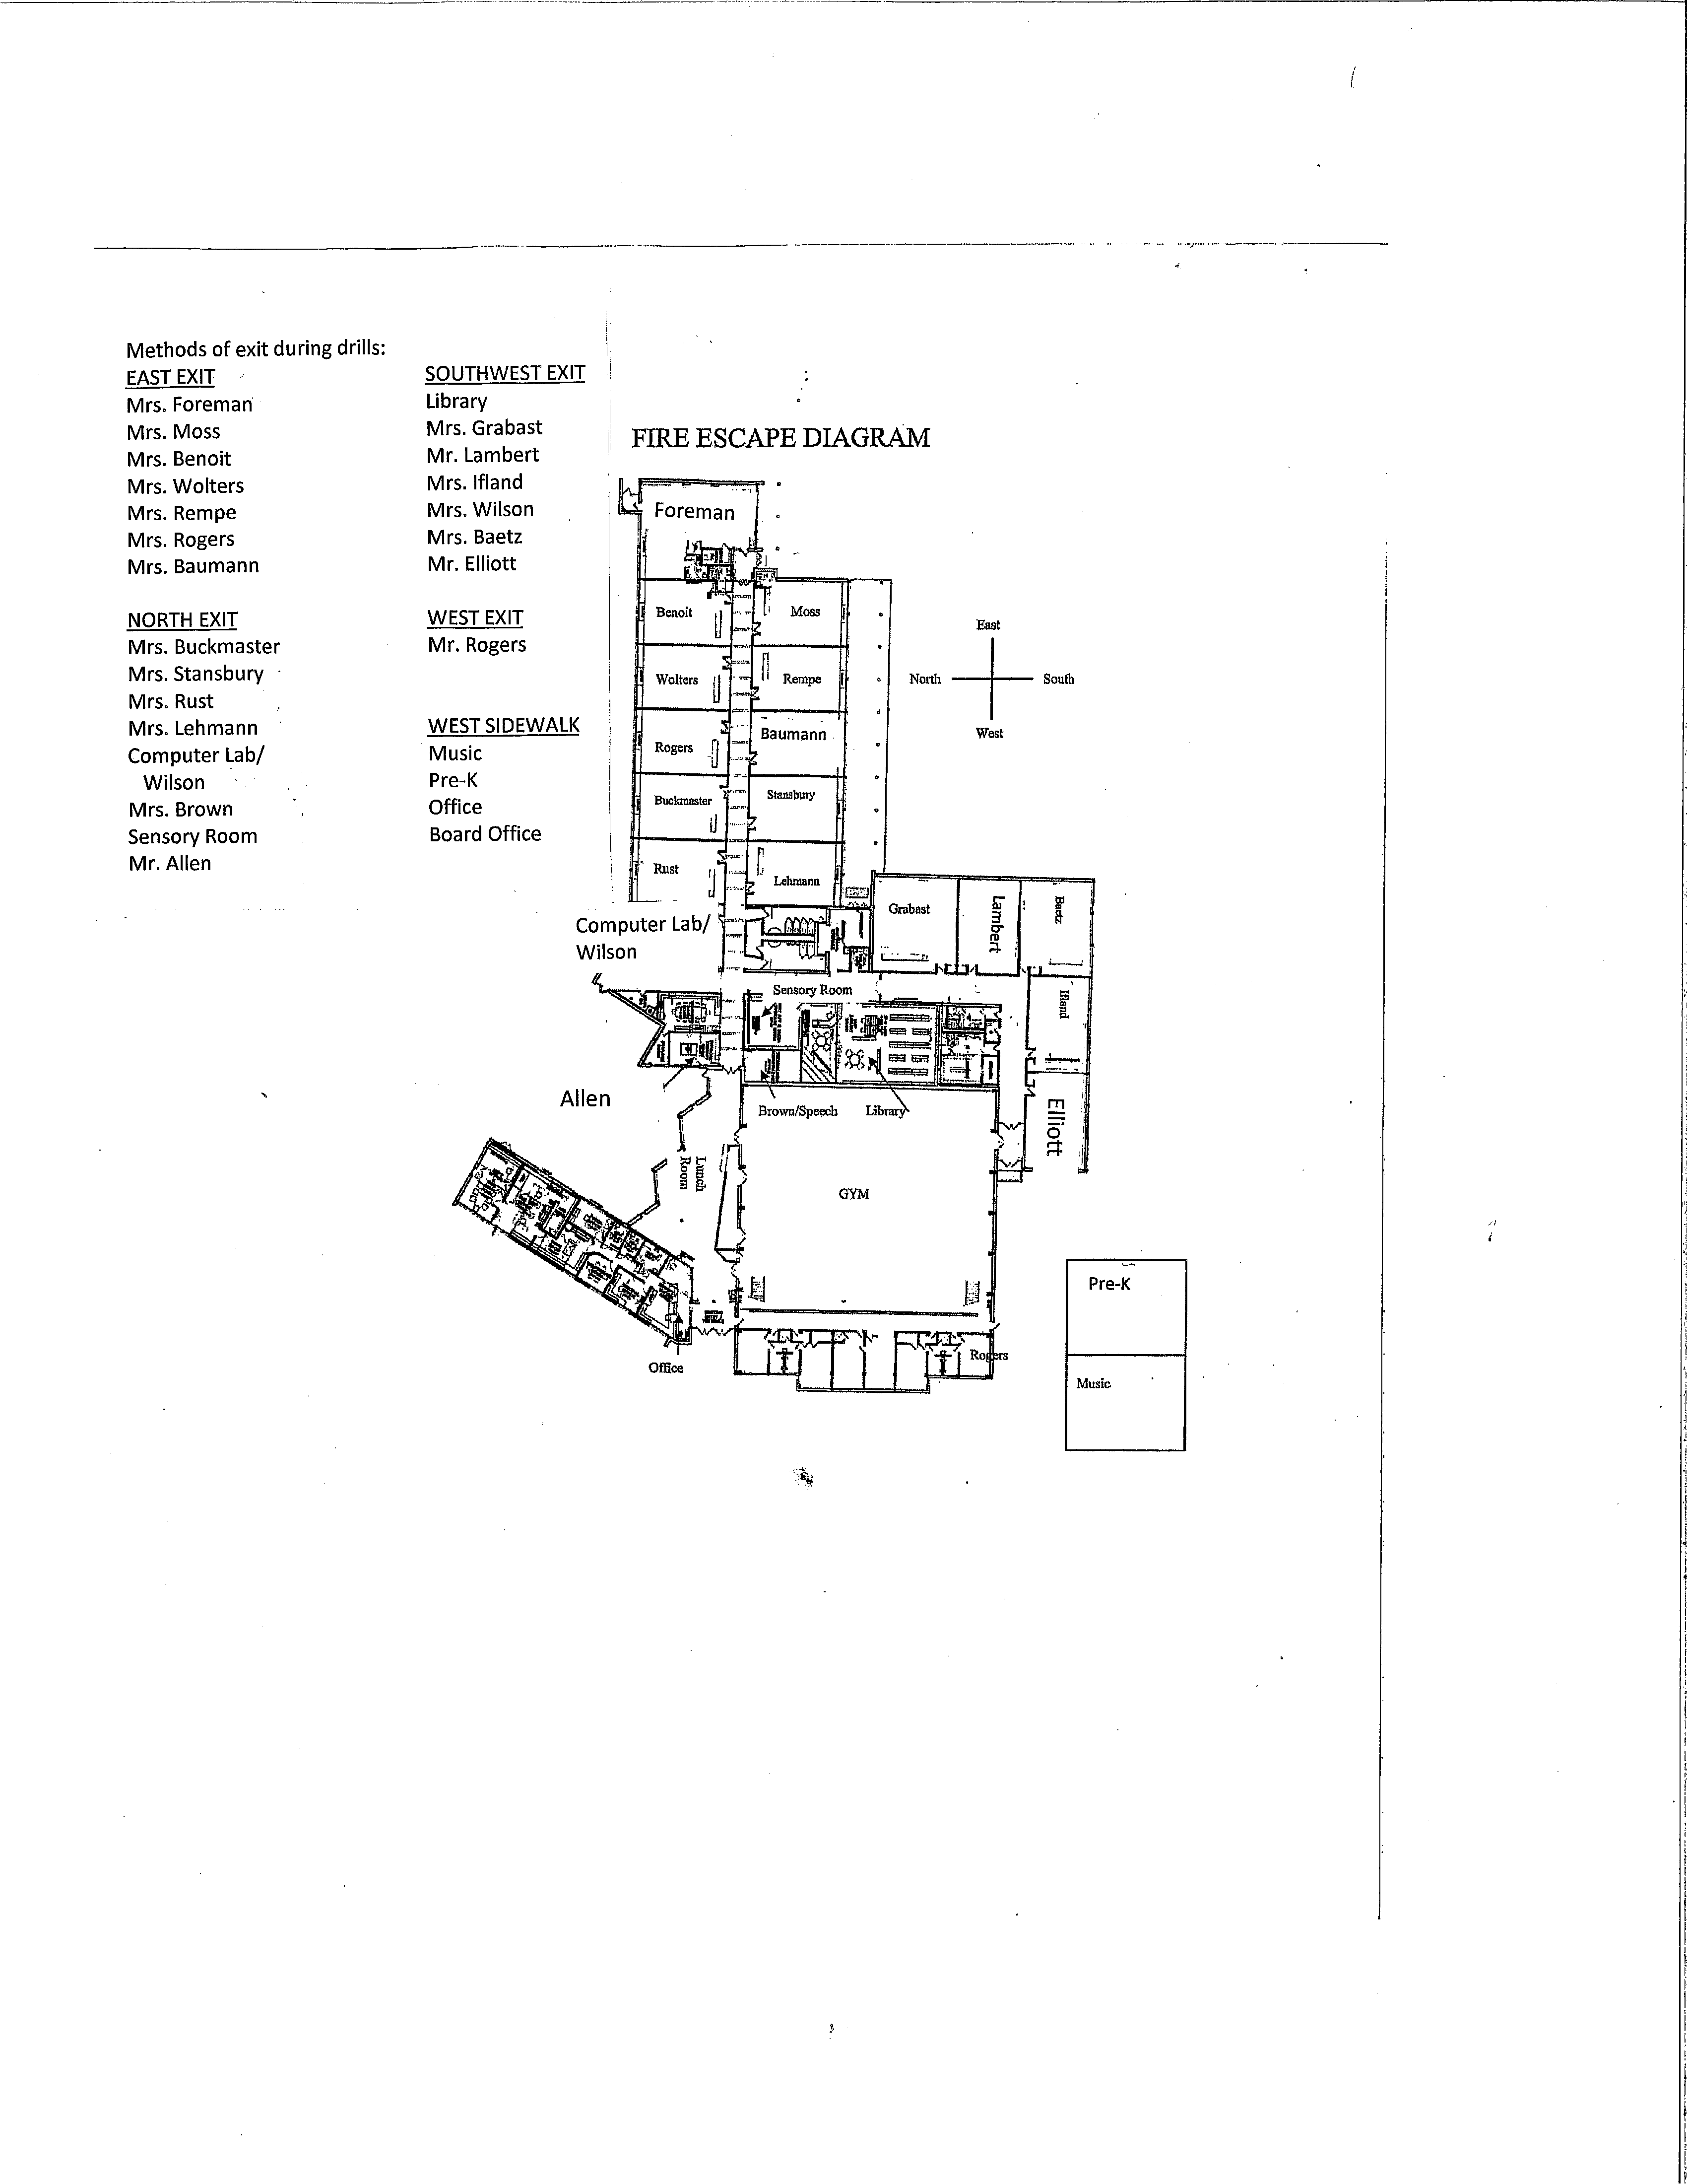

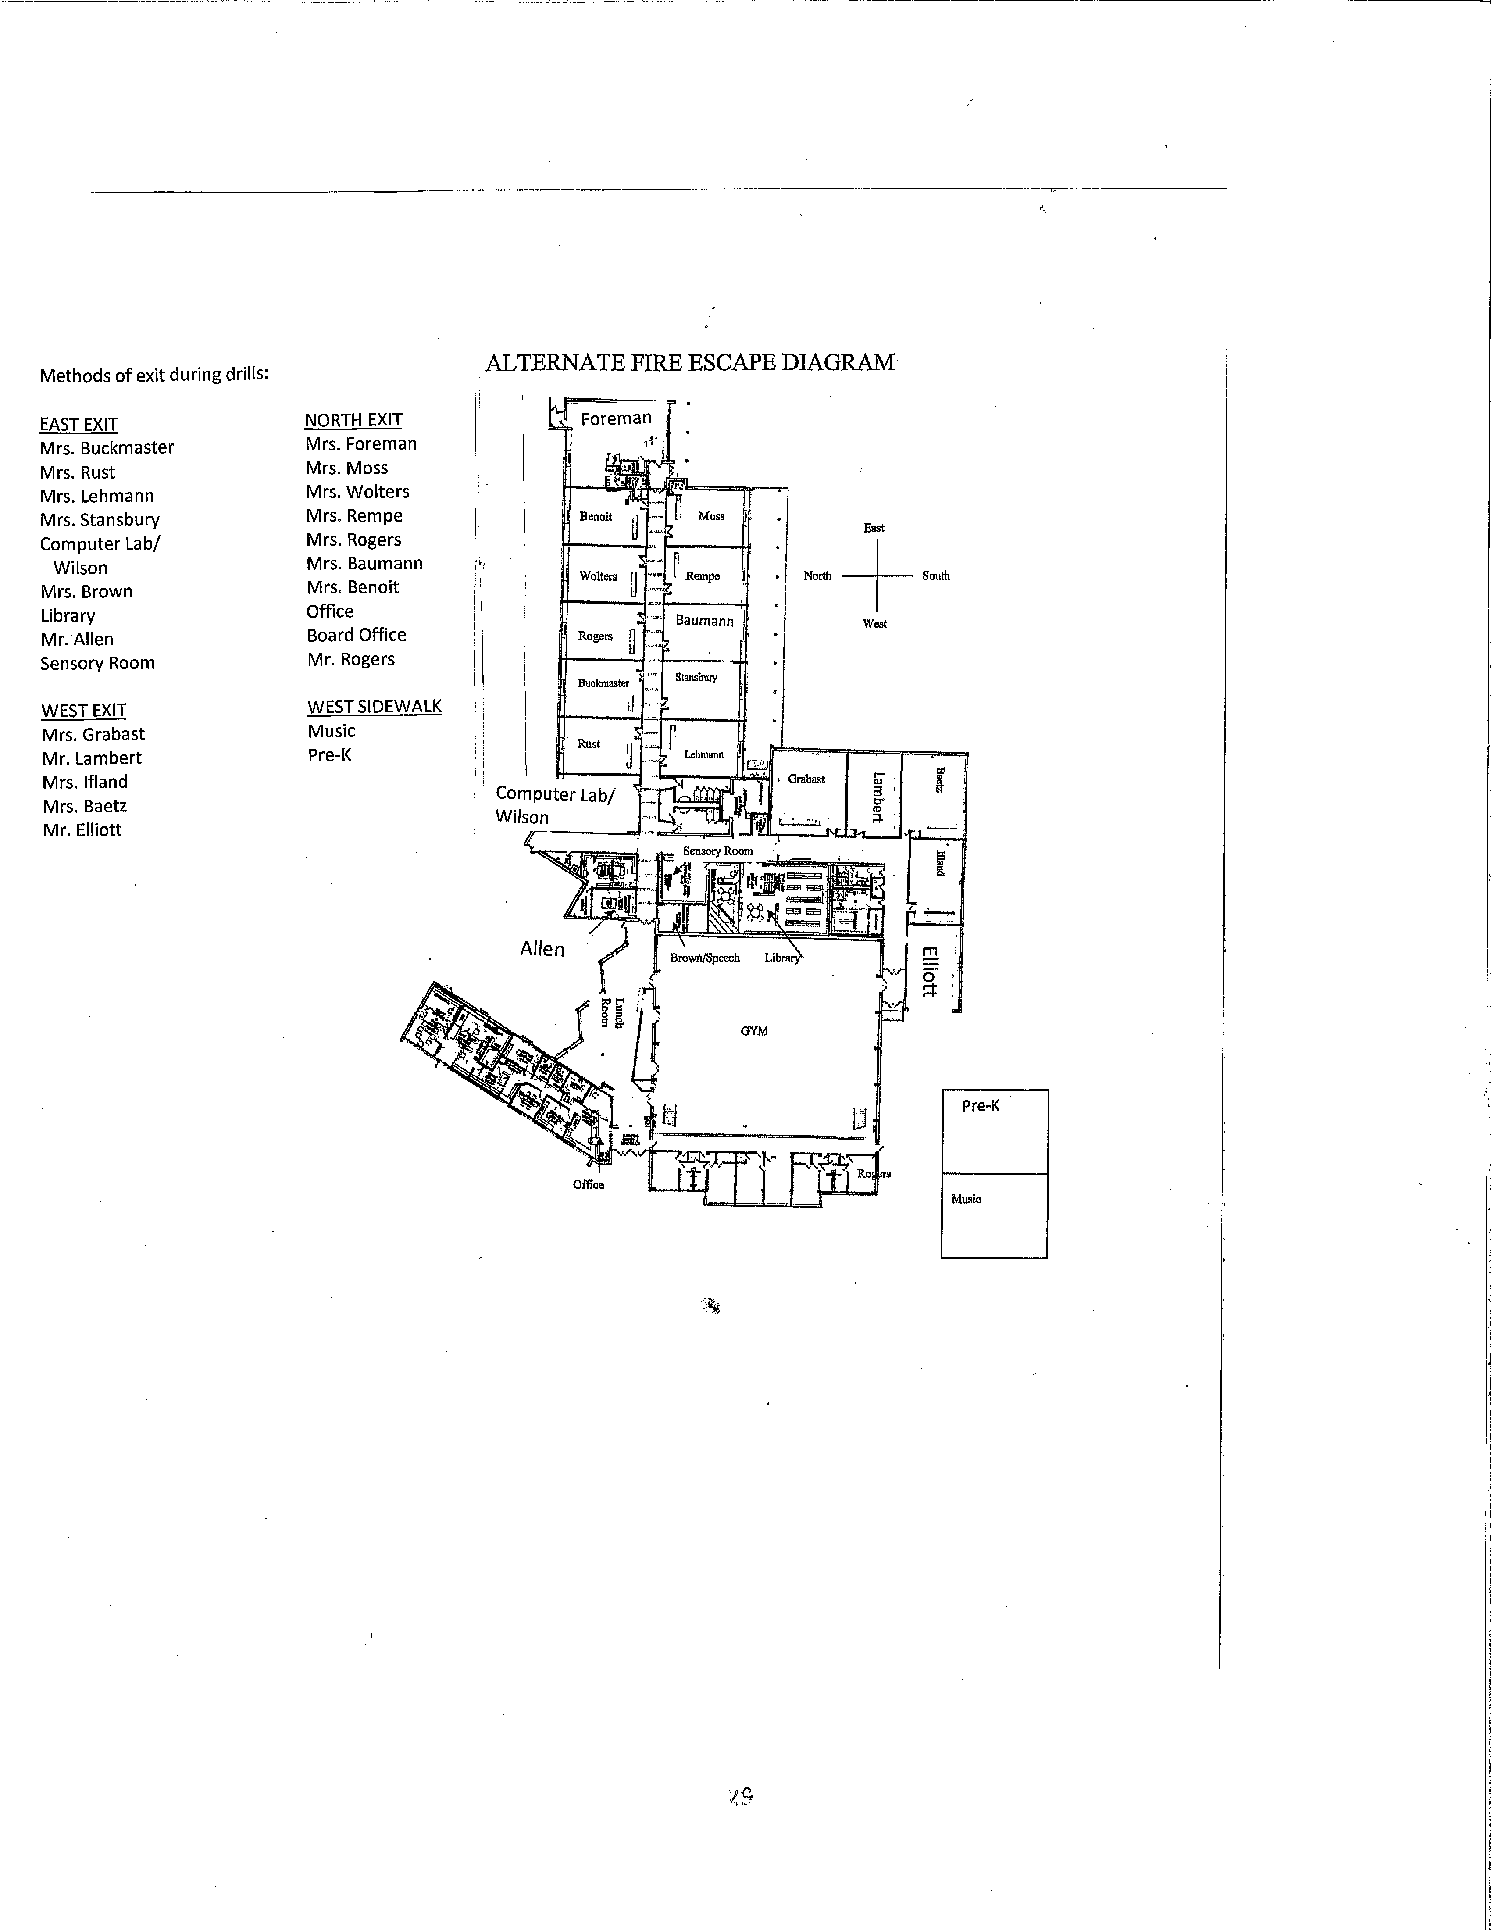

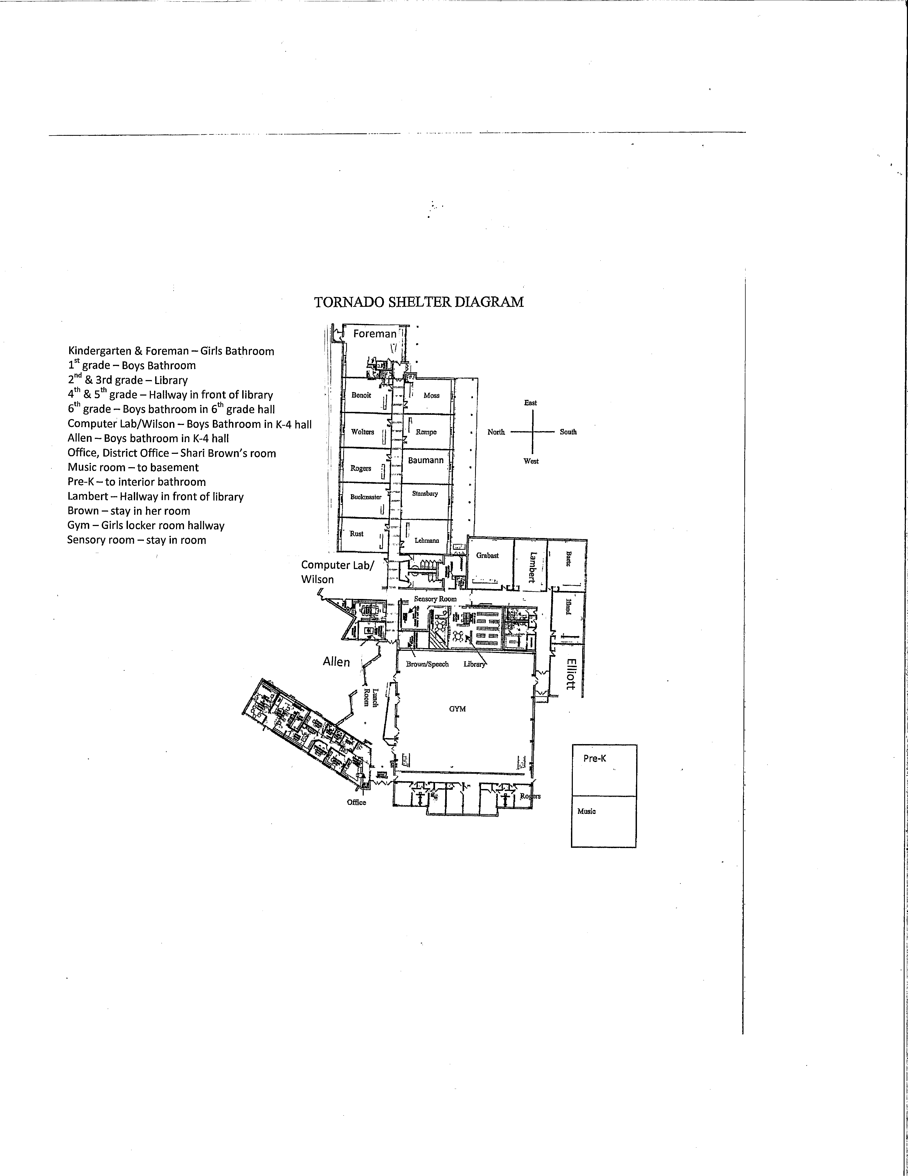

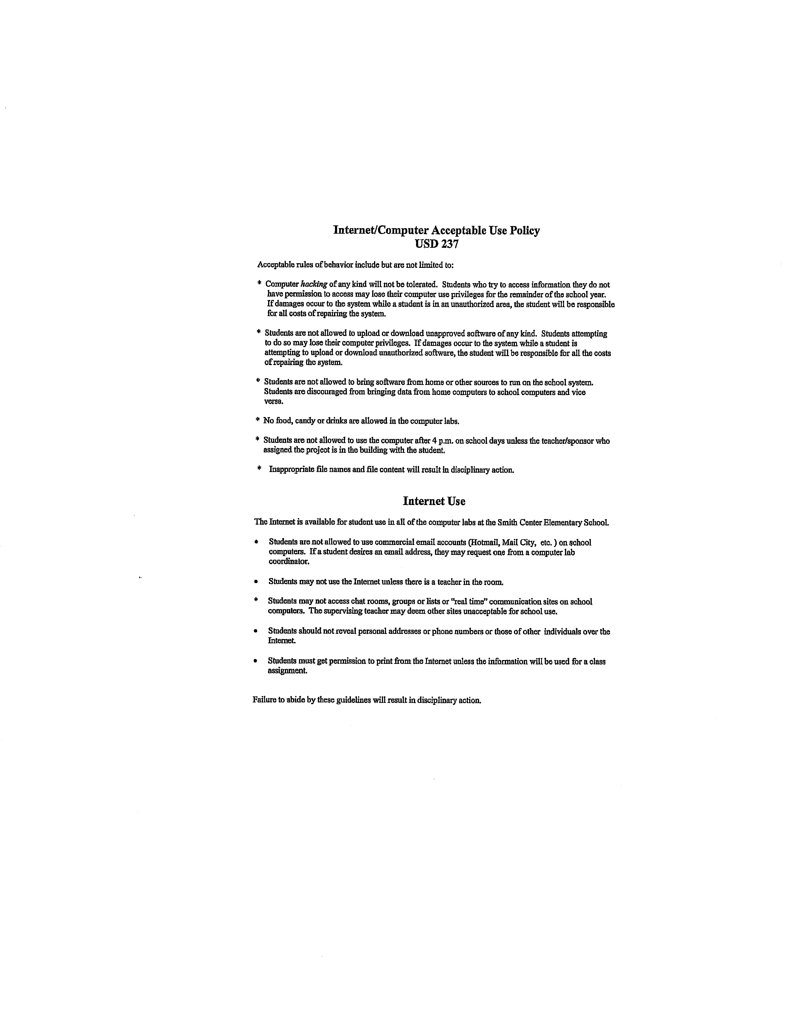

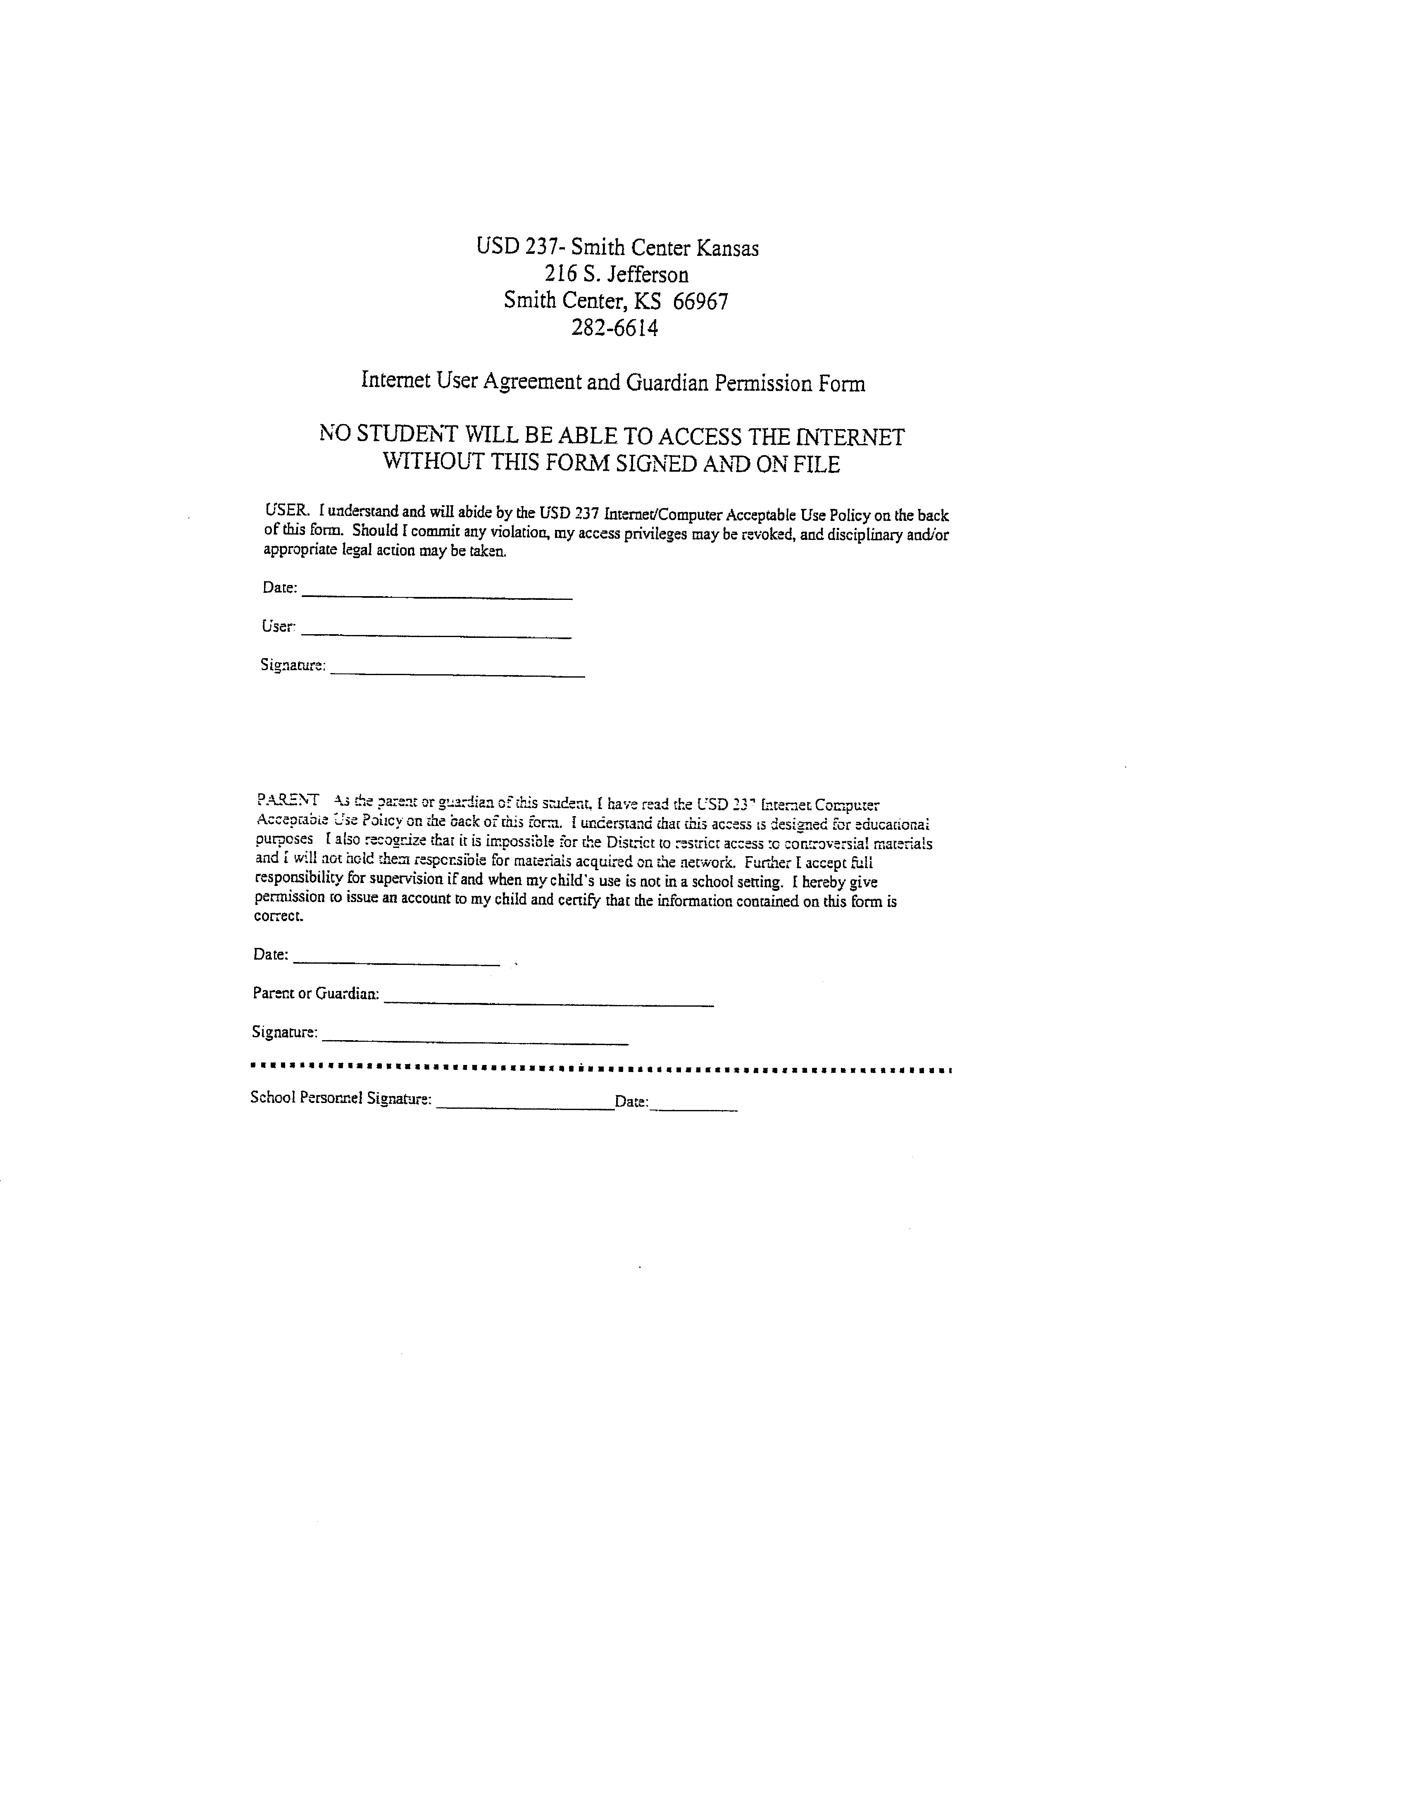

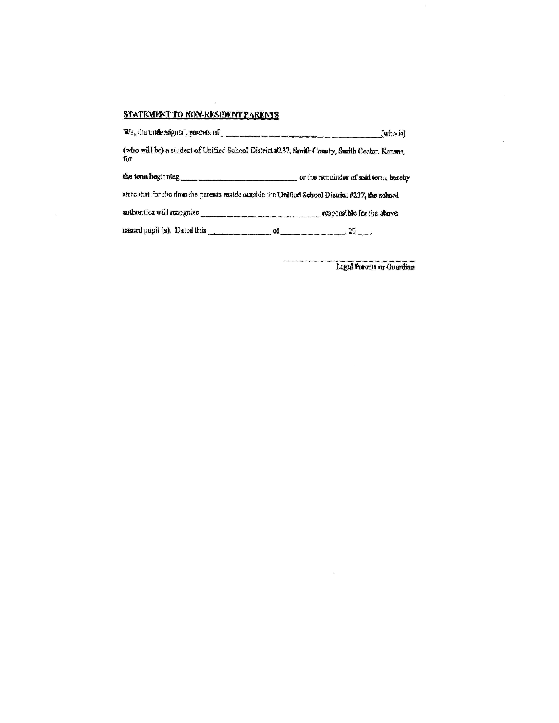

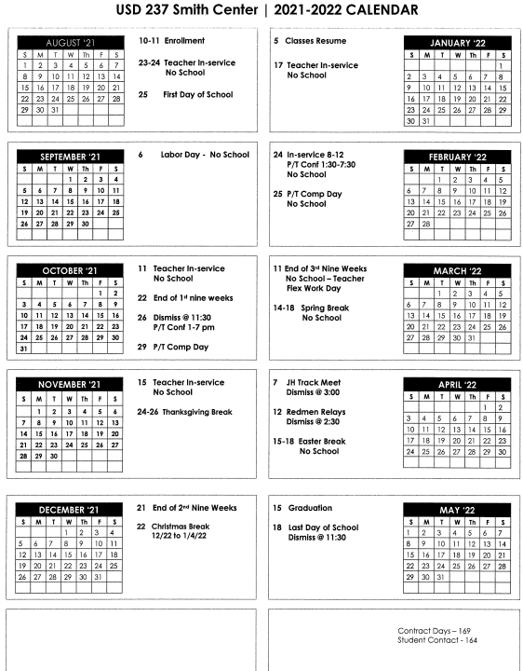

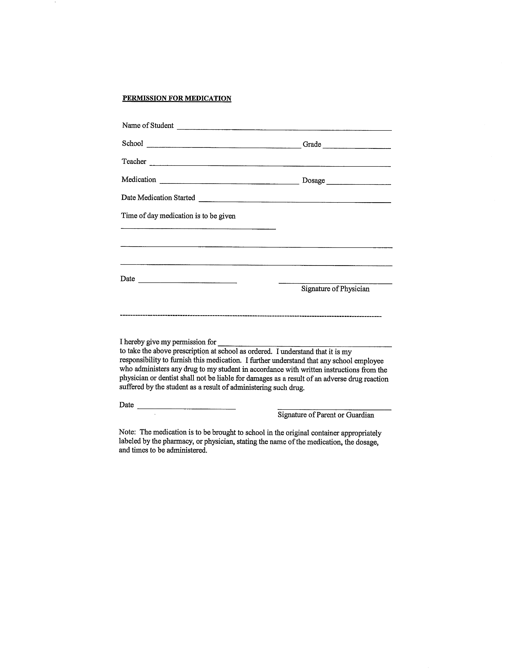

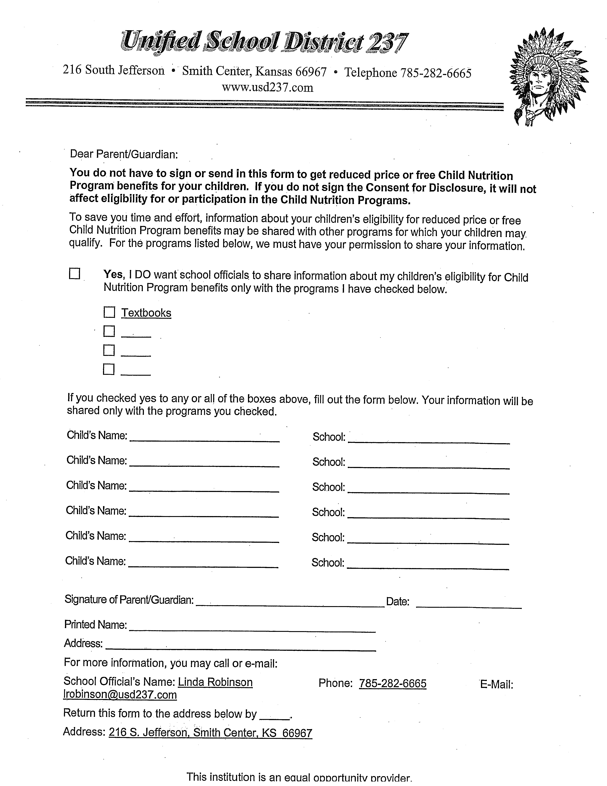

North Central Kansas Special Education Cooperative
Special Education Child Find
This school district and the North Central Kansas Special Education Cooperative (NCKSEC) work together to identify every student, age birth through 21, living within the district boundaries, that has developmental delays or may be in need of special education. If you have a child or know of a child who you think has development delays or special needs, contact the administrator in your district or Cher Greving, Director of NCKSEC at 205 F St. Suite 235; PO Box 369; Phillipsburg, KS 67661 (785-543-2149, fax 785-543-6654, www.ncksec.net).
Areas of special education include: birth through age two (infant-toddler), early childhood - disability, developmentally delayed, visual impairments including blindness, hearing impairments including deafness, deaf-blindness, autism, traumatic brain injury, emotional disturbance, specific learning disabilities, mental retardation, multiple disabilities, orthopedic impairments, other health impairments, speech or language impairments, and gifted.
Parents are advised that all special education services are designed to offer the utmost in educational opportunities for each qualifying student, as well as to provide assistance and support in the areas of physical, mental, emotional, and social growth. State and federal laws are followed in providing each student with a free appropriate public education in the least restrictive environment. If you have a child or know of a child who may need special education services, please notify the school district or the NCKSEC.

Notification of Rights under FERPA
The Family Educational Rights and Privacy Act (FERPA) affords parents and students over 18 years of age ("eligible students") certain rights with respect to the student's education records. These rights are:
(1) The right to inspect and review the student's education records within 45 days of the day the School receives a request for access.
Parents or eligible students should submit to the School principal [or appropriate school official] a written request that identifies the record(s) they wish to inspect. The School official will make arrangements for access and notify the parent or eligible student of the time and place where the records may be inspected.
(2) The right to request the amendment of the student’s education records that the parent or eligible student believes are inaccurate.
Parents or eligible students may ask the School to amend a record that they believe is inaccurate. They should write the School principal [or appropriate school official], clearly identify the part of the record they want changed, and specify why it is inaccurate. If the School decides not to amend the record as requested by the parent or eligible student, the School will notify the parent or eligible student of the decision and advise them of their right to a hearing regarding the request for amendment. Additional information regarding the hearing procedures will be provided to the parent or eligible student when notified of the right to a hearing.
(3) The right to consent to disclosures of personally identifiable information contained in the student's education records, except to the extent that FERPA authorizes disclosure without consent.
One exception, which permits disclosure without consent, is disclosure to school officials with legitimate educational interests. A school official is a person employed by the School as an administrator, supervisor, instructor, or support staff member (including health or medical staff and law enforcement unit personnel); a person serving on the School Board; a person or company with whom the School has contracted to perform a special task (such as an attorney, auditor, medical consultant, or therapist); or a parent or student serving on an official committee, such as a disciplinary or grievance committee, or assisting another school official in performing his or her tasks.
A school official has a legitimate educational interest if the official needs to review an education record in order to fulfill his or her professional responsibility.
Upon request, the School discloses education records without consent to officials of another school district in which a student seeks or intends to enroll.
(4) The right to file a complaint with the U.S. Department of Education concerning alleged failures by the School District to comply with the requirements of FERPA. The name and address of the Office that administers FERPA are: Family Policy Compliance Office; U.S. Department of Education; 400 Maryland Avenue, SW; Washington, DC 20202.

Disclosure of Directory Information under FERPA
Schools may disclose, without consent, "directory" information such as a student's name, address, telephone number, date and place of birth, honors and awards, and dates of attendance. However, schools must tell parents and eligible students about directory information and allow parents and eligible students a reasonable amount of time to request that the school not disclose directory information about them. If you do not want your student’s directory information released, please notify your local school district office of your desire to “opt out”
.R 8/2021
HARASSMENT POLICIES AND PROCEDURES

Sexual Harassment
The board of education is committed to providing a positive and productive learning and
working environment, free from discrimination on the basis of sex, including sexual harassment. Sexual
harassment shall not be tolerated in the school district. Sexual harassment of employees or students of
the district by board members, administrators, certificated and support personnel, students, vendors,
and any others having business or other contact with the school district is strictly prohibited.
Sexual harassment is unlawful discrimination of the basis of sex under Title IX of the Education
Amendments of 1972, Title VII of the Civil Rights Act of 1964, and the Kansas Acts Against Discrimination. All
forms of sexual harassment are prohibited at school, on school property, and at all school-sponsored
activities, programs or events. Sexual harassment against individuals associated with the school is prohibited,
whether or not the harassment occurs on school grounds.
It shall be a violation of this policy for any student, employee or third party (visitor, vendor, etc.) to
sexually harass any student, employee, or other individual associated with the school. It shall further be a
violation for any employee to discourage a student from filing a complaint, or to fail to investigate or refer for
investigation, any complaint lodged under the provisions of this policy. Sexual harassment is unwelcome
sexual advances, requests for sexual favors and other inappropriate oral, written or physical conduct of a
sexual nature when made by a member of the school staff to a student or when made by any student to
another student when: (1) submission to such conduct is made, explicitly or implicitly, a term or condition of
the individual’s education: (2) submission to or rejection of such conduct by an individual is used as the basis
for academic decisions affecting that individual: or (3) such conduct has the purpose or effect or interfering
with an individual’s academic or professional performance or creating an intimidating, hostile or offensive
academic environment.
Sexual harassment may result from verbal or physical conduct or written or graphic material. Sexual harassment may include, but is not limited to: verbal harassment or abuse; pressure for sexual activity: repeated remarks to a person, with sexual or demeaning implication; unwelcoming touching: or suggesting or demanding sexual involvement accompanied by implied or explicit threats concerning a student’s grades, participation in extra-curricular activities, etc.
The district encourages all victims of sexual harassment and persons with knowledge of such harassment to report the harassment immediately. The district will promptly investigate all complaints of sexual harassment and take prompt corrective action to end the harassment.
Any student who believes that he or she has been subjected to sexual harassment should discuss the alleged harassment with the building principal, another administrator, the guidance counselor, or another certified staff member. Any school employee who receives a complaint of sexual harassment from a student shall inform the student of the employee’s obligation to report the complaint and any proposed resolution of the complaint to the building principal. If the building principal is the alleged harasser, the complaint shall be reported to the district compliance coordinator. The building principal or district compliance coordinator shall discusss the complaint with the student to determine if it can be resolved. If the matter is not resolved to the satisfaction of the student in this meeting, the student may initiate a formal complaint under the district’s discrimination complaint procedure (See KN)

Complaints received will be investigated to determine whether, under the totality of the circumstances, the alleged behavior constitutes sexual harassment under the definition outlined above. Unacceptable student conduct may or may not constitute sexual harassment, depending on the
nature of the conduct and its severity, pervasiveness and persistence. Behaviors which are
unacceptable but do not constitute harassment may provide ground for discipline under the code of
student conduct.
An employee who witnesses an act of sexual harassment shall report the incident to the
building principal. Employees who fail to report complaints or incidents of sexual harassment to
appropriate school officials may face disciplinary action. School administrators who fail to investigate
and take appropriate corrective action in response to complaints of sexual harassment may also face
disciplinary action.
When a complaint contains evidence of criminal activity or child abuse, the building
coordinator or district coordinator shall report such conduct to the appropriate law enforcement or SRS
authorities (See GAAD).
To the extent possible confidentiality will be maintained throughout the investigation of a
complaint. The desire for confidentiality must be balanced with the district’s obligation to conduct a
thorough investigation, to take appropriate correction action or to provide due process to the accused.
The filing of a complaint or otherwise reporting sexual harassment shall not reflect upon the
individual’s status or grades. Any act of retaliation against any person who has filed a complaint or
testified, assisted or participated in an investigation of a sexual harassment complaint is prohibited.
Any person who retaliates is subject to immediate disciplinary action, up to and including expulsion for a
student or termination of employment for any employee.
False or malicious complaints of sexual harassment may result in corrective disciplinary
action against the complainant.
A summary of this policy and related materials shall be posted in each district facility. The
policy shall also be published in student, parent and employee handbooks as directed by the district
compliance coordinator. Notification of the policy shall be included in the school newsletter or
published in the local newspaper annually.

Racial Harassment: Students
The board of education is committed to providing a positive and productive learning and
working environment, free from discrimination, including harassment, on the basis of race, color or
national origin (“racial harassment”) shall not be tolerated in the school district. Racial harassment of
employees or students of the district by board members, administrators, certificated and support
personnel, student, vendors, and any other having business or other contact with the school district is
strictly prohibited.
Racial harassment is unlawful discrimination on the basis of race, color or national origin
under Titles VI and VII of the Civil Rights Act of 1964, and the Kansas Acts Against Discrimination. All
forms of racial harassment are prohibited at school, on school property, and at all school-sponsored
activities, programs or events. Racial harassment against individuals associated with the school is
prohibited, whether or not the harassment occurs on school grounds.
It shall be a violation of this policy for any student, employee or third party (visitor, vendor,
etc.) to racially harass any student, employee or other individual associated with the school. It shall
further be a violation for any employee to discourage a student from filing a complaint, or to fail to
investigate or refer for investigation, any complaint lodged under the provisions of this policy.

Racial Harassment is racially motivated conducts which:
1. Affords a student different treatment, solely on the basis of race, color or national origin, in a manner which interferes with or limits the ability of the student to participate in or benefit from the services, activities or programs of the school:
2. Is sufficiently severe, pervasive or persistent so as to have the purpose of effect of creating a hostile academic environment: or
3. Is sufficiently severe, pervasive or persistent so as to have the purpose or effect of interfering with a student’s academic performance or ability to participate in or benefit from the services, activiites or programs of the school.

Racial harassment may result from verbal or physical conduct or written graphic material.
The district encourages all victims of racial harassment and persons with knowledge of such harassment
to report the harassment immediately. The district will promptly investigate all complaints of racial
harassment and take prompt corrective action to end the harassment.
Any student who believes he or she has been subject to racial harassment or has witnessed
an act of alleged racial harassment, should discuss the alleged harassment with the buidling principal,
another administrator, the guidance counselor, or another certified staff member. Any school employee
who receives a complaint of racial harassment from a student shall inform the student of
the employee’s obligation to report the complaint and any proposed resolution of the complaint to the
building principal. If the building principal is the alleged harasser, the complaint shall be reported to the
district compliance coordinator. The building principal shall discuss the complaint with the student to
determine if it can be resolved. If the matter is not resolved to the satisfaction of the student in this
meeting, the student may initiate a formal complaint under the district’s discrimination complaint
procedure (see KN).
Complaints received will be investigated to determine whether, under the totality of the
circumstances the alleged behavior constitutes racial harassment under the definition outlined above.
Unacceptable student conduct may or may not constitute racial harassment, depending on the nature of
the conduct and its severity, pervasiveness and persistence. Behaviors which are uncceptable but do
not constitute harassment may provide grounds for discipline under the code of student conduct. The
discipline of a student for violation of any provision of the code of the student conduct may be
enhanced if the conduct is racially motivated.
An employee who witnesses an act of racial harassment shall report the incident to the
building principal. Employees who fail to report complaints or incidents of racial harassment to
appropriate school officials may face disciplinary action. School administrators who fail to investigate
and take appropriate corrective action in response to complaints of racial harassment may also face
disciplinary action.
When a complaint contains evidence of criminal activity or child abuse, the compliance
coordinator shall report such conduct to the appropriate law enforcement or SRS authorities. (See
GAAD).
To the extent possible confidentiality will be maintained throughout the investigation of a
complaint. The desire for confidentiality must be balanced with the district’s obligation to conduct a
thorough investigation to take appropriate corrective action or to provide due process the accused.
The filing of a complaint or otherwise reporting racial harassment shall not reflect upon the
student’s status or grades. Any act of retaliation against any person who has filed a complaint or
testified, assisted, or participated in an investigation of a racial harassment complaint is prohibited.

Racial Harassment: Students
Any person who retaliated is subject to immediate disciplinary action, up to and including
expulsion for a student or termination of employment for an employee.
False or malicious complaints of racial harassment may result in corrective or disciplinary
action against the complainant.
A summary of this policy and related materials shall be posted in each district facility. The
policy shall also be published in student, parent and employee handbooks as directed by the district
compliance coordinator. Notification of the policy shall be included in the school newsletter or
published in the local newspaper annually.

KN Complaints
The board encourages all complaints regarding the district to be resolved at the lowest
possible administrative level. Whenever a complaint is made directly to the board as a whole or to a
board member as an individual, it will be referred to the administration for study and possible
resolution.
Discrimination against any individual on the basis of race, color, national origin, sex,
disability, age, or religion in the admission or access to or treatment or employment in the districts
programs and activities is prohibited. Harassment of an individual on any of these grounds is also
prohibited. Joshua Lanning, 216 S. Jefferson, P.O. Box 329, Smith Center, Kansas 66967, 785-282-6665,
has been designated to coordinate compliance with nondiscrimination requirements contained in Title
VI of the Civil Rights Act of 1964, Title VII of the Civil Rights Act of 1964, Title IX of the Education
Amendments of 1972, Section 504 of the Rehabilitation Act of 1973, and the Americans with Disabilities
Act of 1990. Information concerning the provisions of these Acts and the rights provided there under,
are available from the compliance coordinator.

KN-R Complaints About Discrimination or Discriminatory Harassment
Complaints of discrimination or discriminatory harassment by an employee should be
addressed to the employee’s supervisor, the building principal, or the district compliance coordinator.
Complaints by a student should be addressed to the building principal, another administrator, the
guidance counselor, or another certified staff member. Any school employee who receives a
complaint of discrimination or harassment from a student shall inform the student of the employee’s
obligation to report the complaint and any proposed resolution of the complaint to the building
principal. If the building principal is the alleged harasser, the complaint shall be reported to the district
compliance coordinator. Complaints by any other person alleging discrimination should be addressed
to the building or the district compliance coordinator. Complaints about discrimination, including
complaints of harassment will be resolved through the following complaint procedures:

Informal Procedures
The building principal shall attempt to resolve complaints of discrimination or harassment in an informal
manner at the building level. Any school employee who receives a complaint of discrimination
harassment from a student, another employee or any other individual shall inform the individual of the
employee’s obligation to report the complaint and any proposed resolution of the complaint to the
building principal. The building principal shall discuss the complaint with the individual to determine if it
can be resolved. If the matter is resolved to the satisfaction of the individual, the building principal shall
document the nature of the complaint and the proposed resolution of the complaint and forward this
record to the district compliance coordinator. Within 20 days after the complaint is resolved in this
manner, the building compliance coordinator shall contact the complainant to determine if the
resolution of the matter remains acceptable. If the matter is not resolved to the satisfaction of the
individual in the meeting with the building compliance coordinator, or if the individual does not believe
the resolution remains acceptable, the individual may initiate a formal complaint.
Formal Complaint Procedures
- A formal complaint should be filed in writing and contain the name and address of the person filing the complaint. The complaint should briefly describe the alleged violation. If an individual does not wish to file a written complaint and the matter has not been adequately resolved, the building principal may initiate the complaint. Forms for filing written complaints are available in each building office and the central office.
- A complaint should be filed as soon as possible after the conduct occurs, but not later than 180 days after the complainant becomes aware of the alleged violation, unless the conduct forming the basis for the complaint is ongoing.
- If appropriate, an investigation shall follow the filing of the complaint. If the complaint is againist the superintendent, the board shall appoint an investigating officer. In other instances, the investigation shall be conducted by the building principal, the compliance coordinator or another individual appointed by the board. The investigation shall be informal but thorough. All interested persons, including the complainant and the person against whom the complaint Is lodged, will be affored an opportunity to submit written or oral evidence relevant to the complaint.
- A written determination of the complaint’s validity and a description of the resolution shall be isssued by the investigator, and a copy forwarded to the complainant no later than 30 days after the filing of the complaint.

- If the investigation results in a recommendation that a student be suspended or expelled, procedures outlined in board policy and state law governing student
suspension and expulsion will be followed.

- If the investigation results in a recommendation that an employee be suspended without pay or terminated, procedures outlined in board policy, the negotiated agreement or state law will be followed.
- Records relating to complaints filed and their resolution shall be forwarded to and
maintained in a confidential manner by the district compliance coordinator.

- The complainant may appeal the determination of the complaint. Appeals shall be
heard by the district compliance coordinator, a hearing officer appointed by the board, or by the board itself as determined by the board. The request to appeal the resolution shall be made within 20 days after the date of the written resolution of the complaint at the lower level. The appeal officer shall review the evidence gathered by the investigator and the investigator’s report, and shall afford the complainant and the person against whom the complaint is filed an opportunity to submit further evidence, orally or in writing, within 10 days after the appeal is filed. The appeal officer will issue a written determination of the complaint’s validity and a description of its resolution within 30 days after the appeal if filed.

- Use of this complaint procedure is not a prerequisite to the pursuit of any other
remedies including the right to file a complaint with the Office for Civil Rights of the U.S. Department of Education, the Equal Employment Opportunity Commission, or the Kansas Human Rights Commission.

About Policy
The superintendent shall report any unresolved complaint about policies to the board at the next regularly scheduled board meeting.
About Curriculum (See IF)
The superintendent shall report a failure to resolve any complaint about curriculum to the board at the
next regularly scheduled board meeting.
About Instructional Materials
The building principal shall report any unresolved complaint about instructional materials to the
superintendent immediately after receiving the complaint.
About Facilities and Services
The superintendent shall report any unresolved complaint about facilities and services to the board at
the next regularly scheduled board meeting.
About Personnel
The superintendent or the building principal involved shall report any unresolved complaint about
personnel to the board at the next regularly scheduled board meeting.

STUDENT RECORDS POLICY OF U.S.D. #237
The Board of Education of U.S.D. #237 interprets current and former students’ records, except
directory information, to be confidential. Proper safeguards and procedures shall be
established and implemented to govern access of student records to all parties within and
outside the school system. All procedure utilized is consistent with the intent of the Family
Rights and Privacy Act of 1974, as amended.
ANNUAL NOTIFICATION
Annual notification of the parent(s) or eligible student rights and procedures for obtaining access
to school records will be published in the local county (Smith) newspaper in August of each
school year. The publication will occur two weeks prior to the opening day of school.
AVAILABILITY OF POLICY
Copies of said written policy will be made available upon request of the parent(s) or eligible
student.
STUDENT RECORDS
All student records shall be treated as confidential and primarily for local school use unless
otherwise stipulated. When records include information on more than one student, the
parents/guardians of any student shall have access to copies of that part of the record that
pertains to their child. Each school shall establish procedures for the granting of a request by
parents/guardians for access to their child’s school records within a reasonable period of time,
but in no case more than 45 days after the request has been made.

In situations where the parents of a student are divorced or separated, each parent, custodial
and/or non-custodial, shall have equal rights to their child’s records unless a court order
specifies otherwise. Private agreements between the student’s parents shall not be recognized
by the district’s personnel.
Parents/guardians shall have an opportunity for a hearing to challenge the content of their
child’s school records to ensure that the records are not inaccurate, misleading or otherwise in
violation of the privacy or other rights of students; to have an opportunity for the correction or
deletion of any inaccurate, misleading or otherwise inappropriate data contained therein; and
to insert into records the parent’s/guardian’s written explanation of the content of the records.

Any eligible parent/guardian or student may inspect the personal records of the student during
regular school office hours. The district reserves the right to interpret selected records to
students and/or parents/guardians at the time of the inspection.

When a student attains 18 years or age, the permission or consent required of and the rights
accorded to the parents of the student shall thereafter only be required of and accorded to the
student.

The parents/guardians of students, or the students if they are 18 years of age or older, shall be
informed annually by the superintendent of the rights accorded them by this section and by the
Family Educational Rights and Privacy Act. In addition, the public shall be informed annually by
the superintendent of the categories of information the institution has determined to be
directory information.

TYPES OF RECORDS
Student record files shall include, but shall not be limited to, the following: administrative, supplemental
and tentative. Information about students collected and stored by any school personnel shall be
separated into one of the following classifications:

Administrative records: official administrative records that constitute the minimum personal
information necessary for operating the educational system. It shall include birth date, sex, race, names,
telephone numbers, addresses and places of employment of parents, academic work completed, grades,
attendance records, withdrawal and re-entry records, honors and activities, date of graduation and
follow-up records of a student.

Supplementary records: verified information important in operating the educational system but is of a
more sensitive nature and of less historical importance. It includes: test data, such as scores on
standardized achievement, aptitude and intelligence tests; observational data such as systematically
gathered teacher or counselor evaluations and observations of social and personal assets; clinical finding
and verified reports of serious or recurrent deviant behavior patterns; general data such as health data,
family background information and educational and vocational plans.

Tentative records: useful information that has not been verified or is not clearly needed beyond the
immediate present. It includes unevaluated reports of teachers or counselors that may be needed in
ongoing counseling or disciplinary actions.

USE OF VIDEO CAMERAS
The district may use video cameras to monitor student activity.

Video cameras may be used to monitor students riding in district vehicles and to monitor student
behavior in or around any district facility.

Videotapes that are records of student behavior shall be secured in a locked file until the tapes are
either reused or erased. The videotape shall be considered a student record and shall be subject to
current law for the release of student record information.

RELEASE OF STUDENT RECORDS
The general public shall not be allowed to inspect a student’s personal record files. The custodian of
student records shall disclose the student’s educational records only as provided for in policy.
Directory Information
Annual notice shall be given to parents and eligible students concerning the student’s records. In
addition, the custodian of the educational records shall give annual public notice of the class of records
the institution has designated as directory information. The appropriate forms for said notices shall be
on file in the office of the custodian of the educational records. The custodian of records may make
directory information available without parental or eligible student’s consent if public notice of the
categories of information designated as directory information has been given and the parents or eligible
students have had the right to object to the release of the information without their consent.

For the purposes of this policy, school official means teacher, administrator, other certified employee or
board of education member. Legitimate educational interest means the school official must participate
in discussions involving an identifiable student leading to educational intervention, disciplinary action,
discussion of eligibility for athletics or other activities, or honors or awards involving a student.

The custodian may disclose student’s education records to the following persons without the prior
consent of the parents.
- Other school officials including teachers within the district who have legitimate educational interest.
- Officials of other schools or school systems in which the student intends to enroll. The school district will forward student records to such institutions without further notice to the parents or eligible student.
- Authorized persons to whom a student has applied for or from whom a student has received financial aid.
- State and local officials or authorities to whom such information is specifically required to be reported or disclosed pursuant to state statutes.
- Organizations conducting studies for educational agencies for the purpose of developing, validating or administering students tests or programs.
- Accrediting organizations
- Parents of a student 18 years of age if parents claim the student as a dependent for income tax purposes
- Appropriate persons if knowledge or any information is necessary to protect the health or safety of the student or other persons in an emergency.

Permission for access will be granted to a third party if requested in writing to the official custodian of the student’s records by the student, parent or guardian.

No personally identifiable information contained in personal school records shall be furnished to any person other than those listed herein and only under the following conditions: when there is written instruction from the student’s parents, guardian or the eligible student specifying the records, the reasons and the person(s) to whom the release is to be made, with a copy of the records to be released made available to the student, parents or guardian when requested; or when information is requested in compliance with a judicial order, or pursuant to any lawfully issued subpoena, upon condition that parents, guardian and the student are notified of the orders or subpoenas in advance of the compliance.

Nothing contained in this policy shall preclude authorized representatives of the Comptroller General of the United States, the Secretary and an administrative head of an educational agency or state authorities from having access to student or other records which may be necessary in connection with the audit and evaluation of federally supported education programs or the enforcement of the federal legal requirements which relate to these programs, provided that, except as the collection of personally identifiable data is specifically authorized by federal law, the data collection by such official with respect to individual students shall not include information (including social security numbers) which would permit the personal identificaton of students or their parents or guardian on the data collected and provided.

With respect to the above, all persons, agencies or organization desiring access to the records of a student shall be required to sign a form which shall be kept permanently with the student’s file, but only for inspection by the parents/guardian, student or a school official responsible for records, maintenance, indicating specifically the legitimate education or other interest of each person, agency or organization has in seeking this information. Such forms shall be available to parents and to the school official responsible for record maintenance as a means of auditing the system’s operation.

Personal information shall be transferred to a third party only on the condition that such party shall not permit any other party to have access to such information without the written consent of the student’s parents or the student if age 18 or older. The board and staff shall protect the rights of privacy of students and their families in connection with any surveys or data-gathering activities conducted, assisted or authorized by the board or administration. Regulations established under this policy shall include provisions controlling the use, dissemination and protection of such data.

HEARING REQUEST
When a hearing has been requested by a parent, guardian or an eligible student to challenge the content of the student’s education record, the procedure to be followed in the hearing shall be: The hearing shall be conducted and the decision rendered by a person who does not have a direct interest in the hearing outcome. The parent, guardian or eligible student shall be given notice of the date, place and time of the hearing within a reasonable time in advance of the hearing.

The parent, guardian or the eligible student may be assisted or represented by individuals of their choice at their own expense, including an attorney. Parents, guardian or the eligible student shall be afforded a full and fair opportunity to present relevant evidence.

A written decision shall be rendered within a reasonable time after the hearing concludes. The decision of the hearing official shall be based solely upon the evidence presented at the hearing and include a summary of the evidence and the reasons for the decision.

DISPOSITION OF RECORDS
All student records will be maintained and screened periodically. Administrative records shall be permanent records and maintained by the school for an indefinite period of time. When the student graduates, supplementary records shall be destroyed or shall be transferred to the administrative records if they have permanent usefulness. Tentative records shall be destroyed when the use for which they were collected is ended. However, tentative records may be placed in the supplementary classification if the continuing usefulness of the information is demonstrated and its validity verified.

The official custodian shall review a student’s records when the student moves from elementary to a middle school or junior high, from a middle school or junior high to high school and upon high school graduation. During each review, obsolete or unnecessary information shall be removed and destroyed.

Following a reasonable amount of time after a student has graduated or ceases to attend school in the district, the records of the student that are determined to be appropriate for retention may be placed on microfilm.

AHERA MANAGEMENT PLAN
In 1986 Congress passed the Asbestos Hazard Emergency Response Act (AHERA). The law
requires all school, kindergarten through twelfth grade, to be inspected to identify an asbestos-
containing building materials. The law further required the development of a Management
Plan, based upon finding of the inspection. The plan outlines the district’s intent in controlling the
potential for exposure to asbestos removal work has been completed by the district according
to the original Management Plan. All copies of the district’s Management Plan and the results
of the three (3) year reinspection are kept on file in each school building.

AN EQUAL EMPLOYMENT/EDUCATIONAL OPPORTUNITY AGENCY
USD 237 Smith Center does not discriminate on the basis of sex, race, color, national origin,
handicap or age in admission or access to, or treatment or employment in its programs or
activities. Any questions regarding the compliance with Title VI, Title IX, or Section 504 may be
directed to Mr. Joshua Lanning, Title IX Coordinator, who can be reached at (785) 282-6665,
216 South Jefferson, Smith Center, Kansas 66967.

ANNUAL NOTICE TO PARENTS AND STUDENTS OF RIGHTS
UNDER THE FAMILY EDUCATIONAL RIGHTS AND PRIVACY ACT

Under the provisions of the Family Educational Rights and Privacy Act (FERPA), parents of
students and eligible students (those who are 18 or older) are afforded various rights with
regard to educational records that are kept and maintained by Unified School District No. 237.
In accordance with FERPA, you are required to be notified of those rights which include:
1. The right to review and inspect all of your educational records, except those
which are specifically exempt. Records will be available for your review within 45 days of the
day the district receives your request for access.
2. The right to prevent disclosure of personally identifiable information contained
in your educational records to other persons, with certain limited exceptions. Disclosure of
information from your educational records to others persons will occur only if:
a. we have your prior written consent for disclosure;
b. the information is considered “directory information” and you have not objected
to the release of such information; or
c. disclosure without your prior consent is permitted by law
The district may disclose, without your consent, personally identifiable information
to school officials with a legitimate educational interest. A school official is a person employed
by the school as an administrator, supervisor, instructor, or support staff member (including
health or medical staff and law enforcement until personnel); the school board (in executive
session); a person or company with whom the school has contracted to perform a special task
(such as an attorney, auditor, medical consultant, or therapist); or a parent or student serving
on an official committee such as a disciplinary or grievance committee, or assisting another
school official in performing his or her tasks. A school official has a legitimate educational
interest if the official needs to review an education record in order to fulfill his or her
professional responsibility or duties.
The district will disclose a student’s education records to officials of another school
district in which the student seeks or intends to enroll without your consent and without
further notice that the records have been requested or forwarded.
3. The right to request that your educational records be amended if you believe the
records are misleading, inaccurate, or otherwise in violation of your rights. This right includes
the right to request a hearing at which you may present evidence to show why the record
should be changed If your request for an amendment to your records is denied in the first
instance.
4. The right to file a complaint with the Family Policy and Regulations Office at the
U.S. Department of Education if you believe that Unified School District No. 237 has failed to
comply with FERPA’s requirement. The address of this office is 400 Maryland Avenue SW,
Room 4074, Washington, DC 20202-4605.
5. The right to obtain a copy of Unified School District No. 237 policies for
complying with FERPA. A copy may be obtained from: Mr. Joshua Lanning, Superintendent of
Schools, 216 South Jefferson, Smith Center, Kansas 66967.

Directory Information: For purposes of FERPA, Unified School District No. 237 has designated
certain information contained in educational records as directory information. This information
may be disclosed for any purpose without your consent. This information can be disclosed
without consent because it is the type of information that would not generally be considered
harmful or an invasion of privacy if disclosed. The following information is considered directory
information: name, address, telephone number, electronic mail address, date and place of
birth, participation in officially recognized activities and sports, weight and height of members
of athletic teams, dates of attendance, degrees, honors and awards received, the most recent
previous school attended by the student, class designation or grade level, enrollment status
(e.g. undergraduate or graduate, full-time or part-time) major field of study and photographs.

You have a right to refuse to permit the designation of any or all of the above information as
directory information. If you refuse, you must file written notification to this effect with Unified
School District No. 237, at the Smith Center Elementary School Office, 216 South Jefferson,
Smith Center, Kansas 66967, on or before September 20th of current school year. If a refusal is
not filed, Unified School District No. 237 assumes you have no objection to the release of
directory information designated.

Recruiting Information: Military recruiters and institutions of higher education are entitled
under federal law to a list of names, addresses, and telephone number of high school students
unless you object to the release of this information. If you notify your principal in writing at any
time that you do not wish your child’s name, address, and telephone number released without
your written consent, we will honor that request.

(NOTE: This recommended form must be retyped and customized to meet district needs in
order to facilitate the disclosure of directory information, the public notice to parents or eligible
students in attendance should:
(1) list the types of personally identifiable information the school has designated as directory information.
(2) note the parent’s or eligible student’s right to refuse to allow the school to disclose any or all of the information designated as directory information; and,
(3) determine the period of time in which the parent or eligible student must notify the school, in writing that he/she does not want any or all of the information designated as directory information.
The school may disclose directory information about a former student without meeting any of
these conditions.

NOTE: Federal law requires that military recruiters be provided with access to names, addresses
and telephone numbers of students, whether or not the information is designated as directory
information under FERPA. Even if you do not designate any information as directory
information, you must give parents notice of the military recruiter’s right and of their right, as a
parent, to prevent the release of this information. This law, which was included as part of the
No Child Left Behind Act, also requires that military recruiters be given the same access to
students at school as postsecondary institutions or prospective employers.

GAAF Emergency Safety Interventions (See GAO, JRB, JQ and KN)
The board of education is committed to limiting the use of Emergency Safety Intervention
(“ESI”), such as seclusion and restraint, with all students. Seclusion and restraint shall be used
only when a student’s conduct necessitates the use of an emergency safety intervention. The
board of education encourages all employees to utilize other behavioral management tools,
including prevention techniques, de-escalation techniques, and positive behavioral intervention
strategies.

Prohibited Types of Restraint
All staff members are prohibited from engaging in the following actions with all students:
- Using face-down (prone) physical restraint;
- Using face-up (supine) physical restraint;
- Using physical restraint that obstructs the student’s airway;
- Using physical restraint that impacts a student’s primary mode of communication;
- Using chemical restraint, except as prescribed treatments for a student’s medical or psychiatric condition by a person appropriately licensed to issue such treatment; and
- Use of mechanical restraint, except:
- Protective or stabilizing devices required by law or used in accordance with an order from a person appropriately licensed to issue the order of the device;
- Any device used by a certified law enforcement officer to carry out law enforcement duties, or
- Seatbelts and other safety equipment when used to secure students during transportation
Use of Seclusion
When a student is placed in seclusion, a school employee shall be able to see and hear the student at all times.

All seclusion rooms equipped with a locking door shall be designed to ensure that the lock automatically disengages when the school employee viewing the student walks away from the seclusion room, or in case of emergency, such as fire or severe weather.

A seclusion room shall be a safe place with proportional and similar characteristics as other rooms where students frequent. Such room shall be free of any condition that could be a danger to the student, well-ventilated, and sufficiently lighted.

Notifications and Documentation
The principal or designee shall notify the parent the same day as an incident. The same-day notification requirement of this subsection shall be deemed satisfied if the school attempts at least two methods of contacting the parent. A parent may designate a preferred method of contact to receive the same-day notification. Also, a parent may agree, in writing, to receive only one same-day notification from the school for multiple incidents occurring on the same day.
Parent Right to Meeting on ESI Use
After each incident, a parent may request a meeting with the school to discuss and debrief the
incident. A parent may request such meeting verbally, in writing, or by electronic means. A
school shall hold a meeting requested under this subsection within 10 school days of the
parent’s request. The focus of any such meeting shall be to discuss proactive ways to prevent
the need for emergency safety interventions and to reduce incidents in the future.
Local Dispute Resolution Process
If a parent believes that an emergency safety intervention has been used on the parent’s child
in violation of state law or board policy, the parent may file a complaint as specified below.
The board of education encourages parents to attempt to resolve issues relating to the use of
ESI informally with the building principal and/or the superintendent before filing a formal
complaint with the board. Once an informal complaint is received, the administrator handling
such complaint shall investigate such matter, as deemed appropriate by the administrator. In
the event that the complaint is resolved informally, the administrator must provide a written
report of the informal resolution to the superintendent and the parents and retain a copy of
the report at the school. The superintendent will share the informal resolution with the board
of education and provide a copy to the state department of education.

If the issues are not resolved informally with the building principal and/or the superintendent,
the parents may submit a formal written complaint to the board of education by providing a
copy of the complaint to the clerk of the board and the superintendent within thirty (30) days
after the parent is informed of the incident.

Upon receipt of a formal written complaint, the board president shall assign an investigator to
review the complaint and report findings to the board as a whole. Such investigator may be a
board member, a school administrator selected by the board, or a board attorney. Such
investigator shall be informed of the obligation to maintain confidentiality of student records
and shall report the findings of fact and recommended corrective action, if any, to the board in
executive session.

Any such investigation must be completed within thirty (30) days of receipt of the formal
written complaint by the board clerk and superintendent. On or before the 30th day after
receipt of the written complaint, the board shall adopt written findings of fact and if necessary,
appropriate correction action. A copy of the written findings of fact and any correction action
adopted by the board shall only be provided to the parents, the school, and the state
department of education and shall be mailed to the parents and the state department within
30 days of the board’s receipt of the formal complaint.

If desired, a parent may file a complaint under the state board of education administrative
review process within (30) days from the date a final decision is issued pursuant to the local
dispute resolution process.

HAZING/HARASSMENT/INTIMIDATION/BULLYING/MENACING

The board is committed to providing a positive and productive learning and working
environment. Hazing, harassment, intimidation, menacing or bullying by student, staff or third
parties is strictly prohibited and shall not be tolerated in the district.

Students whose behavior is found to be in violation of this policy will be subject to discipline, up
to and including expulsion. Staff whose behavior is found to be in violations of this policy will be
subject to discipline, up to and including dismissal. Third parties whose behavior is found to be
in violation of this policy shall be subject to appropriate sanctions as determined and imposed
by the superintendent or board.

Individuals may also be referred to law enforcement officials.

